GCEA Uke  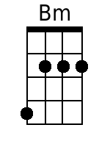  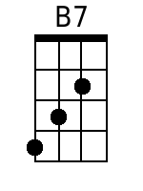  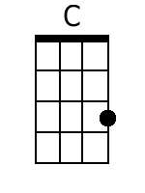  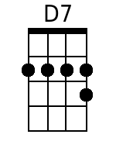  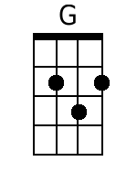  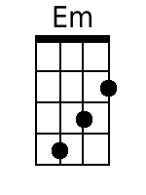  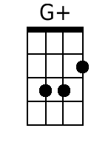  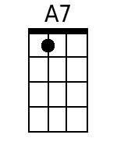 | A Travelin' Man  Authors: Scott Turner and Harry Nilsson, 1963.  Key of G (Original Key of C). “Slowly, with expression.” 3/4 time. GCEA Ukulele  Recorded by The New Christy Minstrels on their 1963 album Ramblin'  4 Measure Intro (Last Line of Chorus):  ♫ |Bm . B7 |C . . |D7 . .|G . |  Chorus:  G C B7 Em  A travel-in' man always longs for a home,  Bm B7 C D7 G  'Cause a travel-in' man is always a-lone.  Last Time Through Add:  G C B7 Em  Yes, a travel-in' man always longs for a home  Bm B7 C D7 G - G  'Cause a travel-in' man is always a-lone.  Verse 1:  G C B7 Em  I've traveled from Maine to the Barbary shore,  Bm B7 C D7 G  But I'm gettin' so weary, I can't travel no more.  G C B7 Em  I rambled the highways and sailed 'cross the sea,  Bm B7 C D7 G  Wond'rin', always wond'rin' where the next stop would be. Chorus.  Bridge:  G B7 C D7 G  Seen the mansions of England, the villas of Rome;  G+ C A7 D7  Each man has his castle, but the road's been my home.  Verse 2:  G C B7 Em  So fair-thee-well ladies, there's none quite so fair,  Bm B7 C D7 G  But a travel-in' man has only one prayer:  G C B7 Em  To be just a farmer with a plow and a hoe,  Bm B7 C D7 G  In-stead of a drifter with no place to go. Chorus.

