A World Without Love (Paul McCartney, ca. 1958)
A World Without Love by Peter And Gordon (1964) – Key of C

Intro (Last line of verse): C | Dm | G7 | C | G#7 G7 | C |  C E7 Am  Please, lock me a-way and don't allow the day.  C Fm C  Here, in-side where I hide with my loneliness.  Dm G7 C | G#7 G7 |  I don't care what they say, I won't stay in a world without love.  C E7 Am  Birds sing out of tune and rainclouds hide the moon.  C Fm C  I'm OK; here I'll stay with my loneliness.  Dm G7 C | C7  I don't care what they say, I won't stay in a world without love.  Bridge  Fm C  __ So I wait and in a while. __ I will see my true love smile.  Fm  __ She may come I know not when.  Dm G#7 G7 C  __ When she does I'll know, so baby until then  E7 Am  Lock me a-way and don't allow the day,  C Fm C  Here, in-side where I hide with my loneliness.  Dm G7 C | G#7 G7 |  I don't care what they say, I won't stay in a world without love.  To Outro: C A  Instrumental (1st verse):  | C | E7 | Am | Am | C | Fm | C | C | C | Dm | G7 | C | C7 |  Repeat From Bridge.  Outro  Dm G7  I don't care what they say, I won't stay  C A | Dm | G7 | C  In a world without love. |  |  |  |  |  |  | 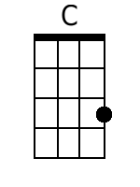 | 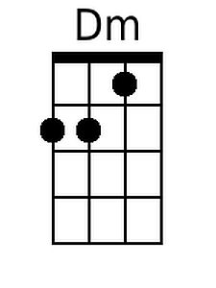
 |  |  |  |  |  |  | 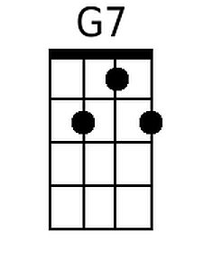 | 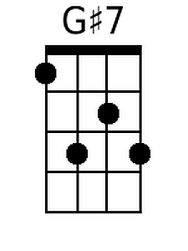
 |  |  |  |  |  |  | 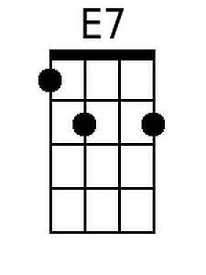 | 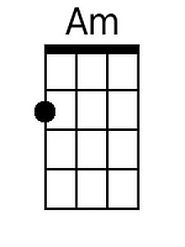
 |  |  |  |  |  |  | 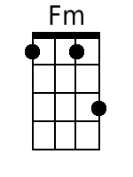 | 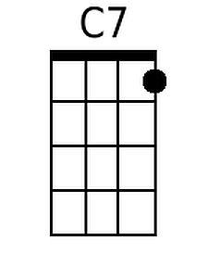
 |  |  |  |  |  |  | 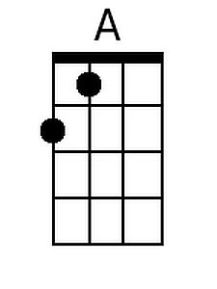
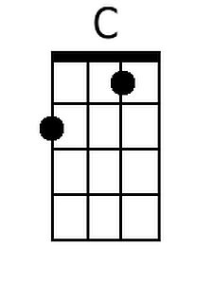 | 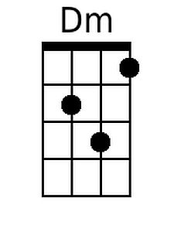 | 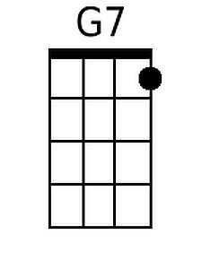 | 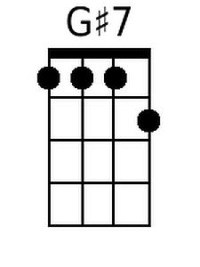 | 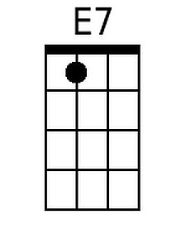 | 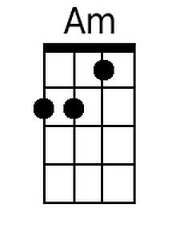 | 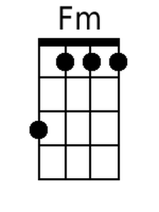 | 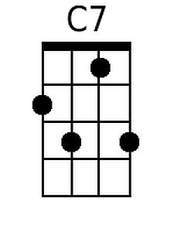 | 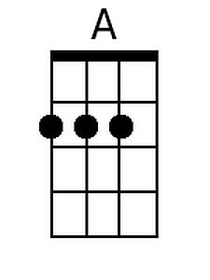

A World Without Love (Paul McCartney, ca. 1958)
A World Without Love by Peter And Gordon (1964) – Key of F

Intro (Last line of verse): F | Gm | C7 | F | C#7 C7 | F |  F A7 Dm  Please, lock me a-way and don't allow the day.  F Bbm F  Here, in-side where I hide with my loneliness.  Gm C7 F | C#7 C7 |  I don't care what they say, I won't stay in a world without love.  F A7 Dm  Birds sing out of tune and rainclouds hide the moon.  F Bbm F  I'm OK; here I'll stay with my loneliness.  Gm C7 F | F7  I don't care what they say, I won't stay in a world without love.  Bridge  Bbm F  __ So I wait and in a while. __ I will see my true love smile.  Bbm  __ She may come I know not when.  Gm C#7 C7 F  __ When she does I'll know, so baby until then  A7 Dm  Lock me a-way and don't allow the day,  F Bbm F  Here, in-side where I hide with my loneliness.  Gm C7 F | C#7 C7 |  I don't care what they say, I won't stay in a world without love.  To Outro: F D  Instrumental (1st verse):  | F | A7 | Dm | Dm | F | Bbm | F | F | F | Gm | C7 | F | F7 |  Repeat From Bridge.  Outro  Gm C7  I don't care what they say, I won't stay  F D | Gm | C7 | F  In a world without love. |  |  |  |  |  |  | 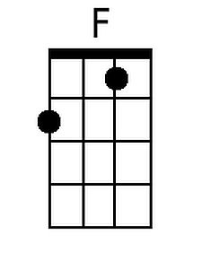 | 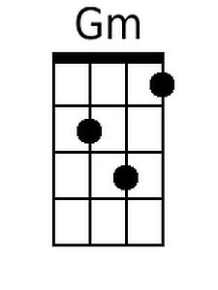
 |  |  |  |  |  |  |  | 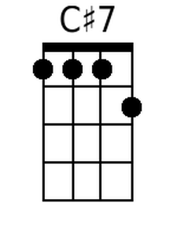
 |  |  |  |  |  |  | 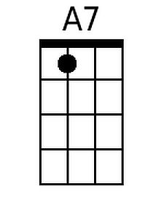
 |  |  |  |  |  |  | 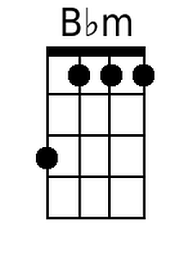 | 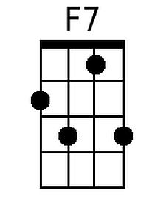
 |  |  |  |  |  |  | 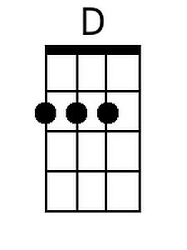
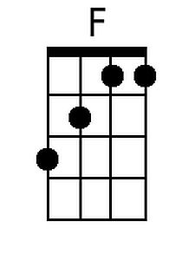 | 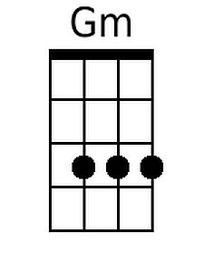 |  | 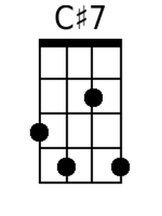 | 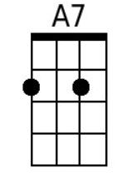 |  | 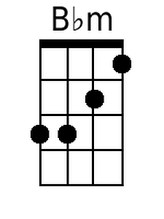 | 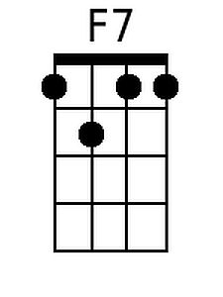 | 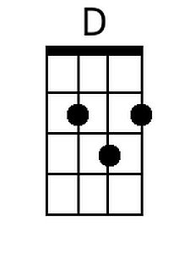

A World Without Love (Paul McCartney, ca. 1958)
A World Without Love by Peter And Gordon (1964) – Key of G

Intro (Last line of verse): G | Am | D7 | G | D#7 D7 | G |  G B7 Em  Please, lock me a-way and don't allow the day.  G Cm G  Here, in-side where I hide with my loneliness.  Am D7 G | D#7 D7 |  I don't care what they say, I won't stay in a world without love.  G B7 Em  Birds sing out of tune and rainclouds hide the moon.  G Cm G  I'm OK; here I'll stay with my loneliness.  Am D7 G | G7  I don't care what they say, I won't stay in a world without love.  Bridge  Cm G  __ So I wait and in a while. __ I will see my true love smile.  Cm  __ She may come I know not when.  Am D#7 D7 G  __ When she does I'll know, so baby until then  B7 Em  Lock me a-way and don't allow the day,  G Cm G  Here, in-side where I hide with my loneliness.  Am D7 G | D#7 D7 |  I don't care what they say, I won't stay in a world without love.  To Outro: G E7  Instrumental (1st verse):  | G | B7 | Em | Em | G | Cm | G | G | G | Am | D7 | G | G7 |  Repeat From Bridge.  Outro  Am D7  I don't care what they say, I won't stay  G E | Am | D7 | G  In a world without love. |  |  |  |  |  |  | 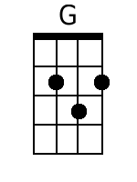
 |  |  |  |  |  |  | 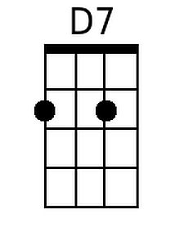 | 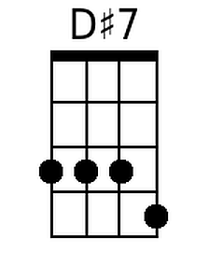
 |  |  |  |  |  |  | 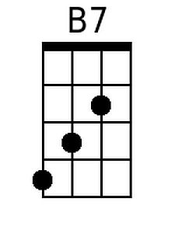 | 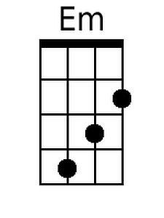
 |  |  |  |  |  |  | 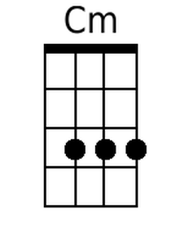
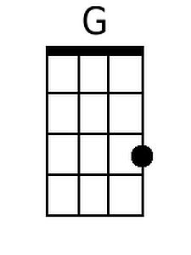 |  | 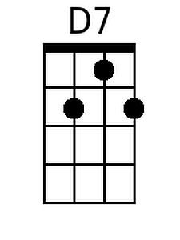 | 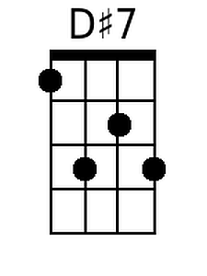 | 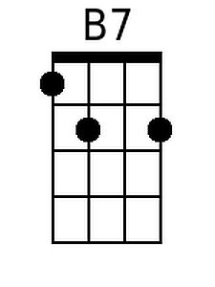 | 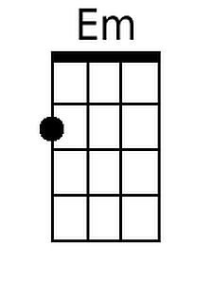 | 