**A World Without Love (John Lennon / Paul McCartney)**

F



Bb

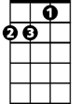

Dm

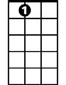

A7

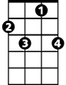

F7



C

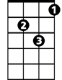

Gm

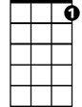

C7

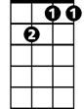

Gm7

**Intro: F Gm7 C7 F (last 2 lines of verse) G# // Bb // F/**

**F A7 Dm**

Please lock me away and don't allow the day

**F Bb F**

Here inside, where I hide with my loneliness

**Gm7**

I don't care what they say

**C7 F C C7**

I won't stay in a world without love

**F A7 Dm**

Birds sing out of tune and rain clouds hide the moon

**F Bb F**

I'm okay, here I stay with my loneliness

**Gm7**

I don't care what they say

**C7 F F7**

I won't stay in a world without love

**Reprise:**

**Gm F**

So I wait and in a while, I will see my true love smile

**Gm**

She may come, I know not when

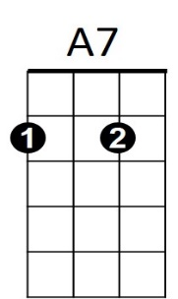**Gm7 C C7 F**

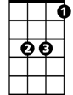

Bb

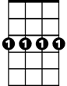

Gm7



C7



F



Dm

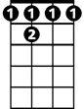

F 7

**BARITONE**

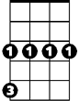

Gm

C



When she does, I'll lose ~ So baby, until then…

**F A7 Dm**

Lock me away and don't allow the day

**F Bb F**

Here inside, where I hide with my loneliness

**Gm7**

I don't care what they say

**C7 F F7**

I won't stay in a world without love

**(Reprise)**

**(Instrumental First two lines of first verse)**

**Gm7**

I don't care what they say

**C7 F Dm**

I won't stay in a world without love

**Gm7**

I don't care what they say

**C7 F**

I won't stay in a world without love

**Ending: Same as Intro**