A World of Our Own (Tom Springfield, 1965; The Seekers) (C)

Intro: C F G / C F G / C F G (2x)  C Em  Close the doors, light the lights,  F C  We're stayin' home to-night,  Em Am  Far away from the bustle  F G7  And the bright city lights.  C E7  Let them all fade away,  F C  Just leave us a-lone.  Em F G7 C F G  And we'll live in a world of our own.  Chorus:  G C F  We'll build a world of our own  G7 C  That no one else can share.  Am D7  All our sorrows we'll leave  G G7  Far be-hind us there.  C E7  And I know you will find,  F C  There'll be peace of mind  Em F G7 C F G  When we live in a world of our own. |  |  | C Em  Oh my love, oh my love,  F C  I cried for you so much.  Em Am  Lonely nights without sleeping  F G7  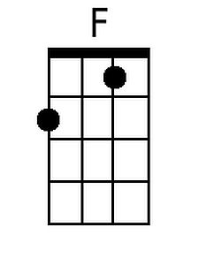  While I longed for your touch.  C E7  Now your lips can erase,  F C  The heartache I've known.  Em F G7 C F G  Come with me to a world of our own.  Chorus.  Outro:  C E7  And I know you will find,  F C  There'll be peace of mind  Em F Em  When we live in a world of our own.  C F G7 C  When we live in a world of our own  F G / C F G / C F G C |  |  | 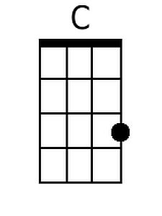  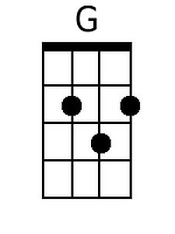  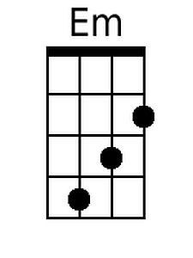  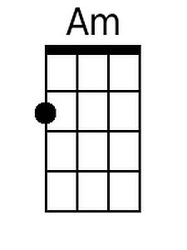  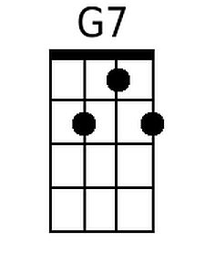  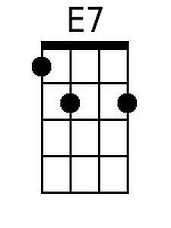  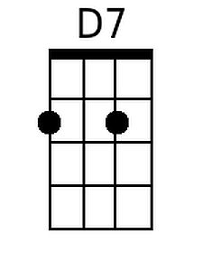
Bari
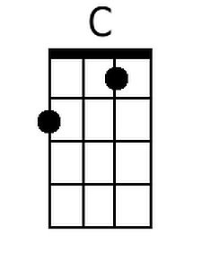 | 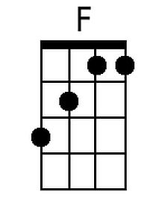 | 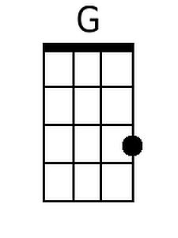 | 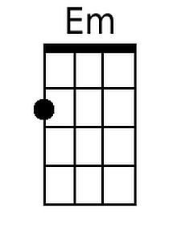
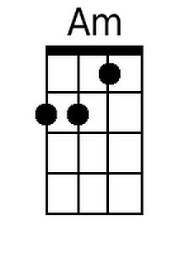 | 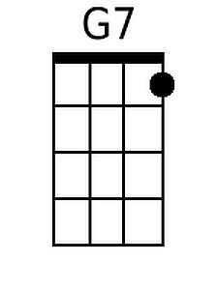 | 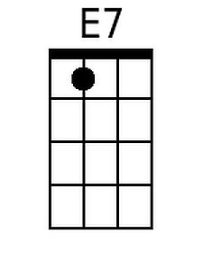 | 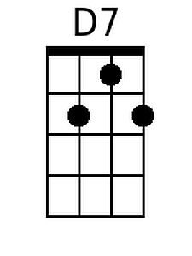

A World of Our Own (Tom Springfield, 1965; The Seekers) (G)

Intro: G C D / G C D / G C D (2x)  G Bm  Close the doors, light the lights,  C G  We're stayin' home to-night,  Bm Em  Far away from the bustle  C D7  And the bright city lights.  G B7  Let them all fade away,  C G  Just leave us a-lone.  Bm C D7 G C D  And we'll live in a world of our own.  Chorus:  D G C  We'll build a world of our own  D7 G  That no one else can share.  Em A7  All our sorrows we'll leave  D D7  Far be-hind us there.  G B7  And I know you will find,  C G  There'll be peace of mind  Bm C D7 G C D  When we live in a world of our own. |  |  | G Bm  Oh my love, oh my love,  C G  I cried for you so much.  Bm Em  Lonely nights without sleeping  C D7  While I longed for your touch.  G B7  Now your lips can erase,  C G  The heartache I've known.  Bm C D7 G C D  Come with me to a world of our own.  Chorus.  Outro:  G B7  And I know you will find,  C G  There'll be peace of mind  Bm C Bm  When we live in a world of our own.  G C D7 G  When we live in a world of our own  C D / G C D / G C D G |  |  | 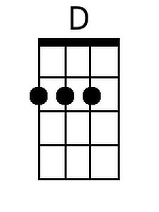  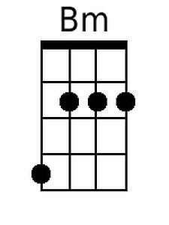  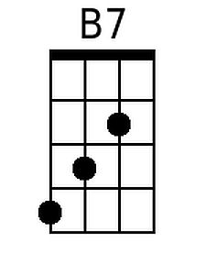  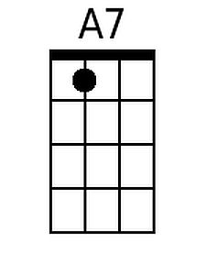
Bari
 |  | 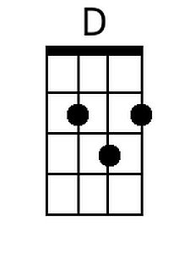 | 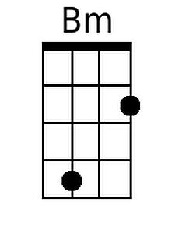
 |  | 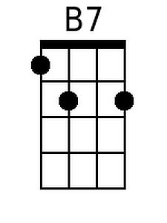 | 