**A World of Our Own (Seekers)**

**Intro: C F G / C F G / C F G 2x**

**C Em**

Close the doors, light the lights,

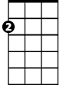

Am

E7

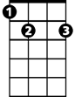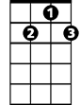

G7



G

F



Em

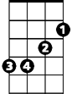

C

**F C**

We're stayin' home tonight,

**Em Am F G7**

Far away from the bustle and the bright city lights.

**C E7 F C**

Let them all fade away, just leave us alone.

**Em F G7 C F G**

And we'll live in a world of our own.

**Chorus:**

**G C F**

We'll build a world of our own

**G7 C**

That no one else can share.

**Am D7 G G7**

All our sorrows we'll leave far behind us there.

**C E7 F C**

And I know you will find, there'll be peace of mind

**Em F G7 C F G**

When we live in a world of our own.

**BARITONE**



F



Em



G

C



**C Em**

Oh my love, oh my love,

**F C**

I cried for you so much.

**Em Am F G7**

Lonely nights without sleeping while I longed for your touch.

**C E7 F C**

Now your lips can erase, the heartache I've known.

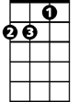

Am

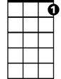

G7

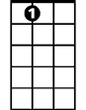

E7

**Em F G7 C F G**

Come with me to a world of our own.

**(Chorus)**

**G C F**

We'll build a world of our own

**G7 C**

That no one else can share.

**Am D7 G G7**

All our sorrows we'll leave far behind us there.

**C E7 F C**

And I know you will find, there'll be peace of mind

**Em F G7 C F G**

When we live in a world of our own.

**C E7 F C**

And I know you will find, there'll be peace of mind

**Em F Em**

When we live in a world of our own

**C F G7 C F G / C F G / C F G C**

When we live in a world of our own