**Abracadabra (Steve Miller)**

**Am Dm**

I heat up, I can’t cool down

**E7 Am**

You got me spinnin, round and round

**Am Dm**

Round and round and round it goes

**E7 Am**

Where it stops nobody knows

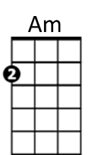**Am Dm**

Every time you call my name

**E7 Am**

I heat up like a burnin flame

**Am Dm**

Burnin flame full of desire

**E7**

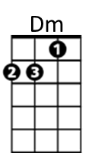Kiss me baby, let the fire get higher

**Chorus:**

**Am Dm**

Abra-abra-cadabra

**E7 Am**

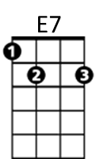I want to reach out and grab ya

**Am Dm**

Abra-abra-cadabra

**E7 Am**

Abracadabra

**Am Dm**

You make me hot, you make me sigh

**E7 Am**

You make me laugh, you make me cry

**Am Dm**

Keep me burnin’ for your love

**E7 Am**

With the touch of a velvet glove

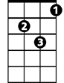

Dm

**BARITONE**

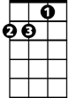

Am

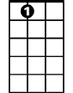

E7

**(Chorus)**

**Am Dm**

I feel the magic in your caress

**E7 Am**

I feel magic when I touch your dress

**Am Dm**

Silk and satin, leather and lace

**E7 Dm**

Black panties with an angels face

**Am Dm**

I see magic in your eyes

**E7 Am**

I hear the magic in your sighs

**Am Dm**

Just when I think I’m gonna get away

**E7 Am**

I hear those words that you always say

**(Chorus)**

**Am Dm**

Every time you call my name

**E7 Am**

I heat up like a burnin’ flame

**Am Dm**

Burnin flame full of desire

**E7**

Kiss me baby, let the fire get higher

**Am Dm**

I heat up, I can’t cool down

**E7 Am**

My situation goes round and round

**Am Dm**

I heat up, I can’t cool down

**E7 Am**

My situation goes round and round

**Am Dm**

I heat up, I can’t cool down

**E7 Am**

My situation goes round and round