**Against the Wind (Bob Seeger)**

**Intro: C Em F C (2x)**

**C Em**

It seems like yesterday, but it was long ago

**F C**

Janie was lovely, she was the queen of my nights

**G F**

There in the darkness with the radio playing low.

**C Em**

The secrets that we shared, the mountains that we moved

**F C**

Caught like a wild fire out of control

**F G**

Till there was nothing left to burn and nothing left to prove.

**Am G C**

And I remember what she said to me

**Am F C**

How she swore that it never would end

**Am G F**

I remember how she held me oh so tight,

**G**

Wish I didn't know now what I didn't know then.

**C Em F C**

Against the wind, we were running against the wind.

**F Em Dm**

We were young and strong, we were running …

**F C**

Against the wind.

**C Em**

The years rolled slowly past, I found myself alone,

**F C**

Surrounded by strangers I thought were my friends,

**G F**

I found myself further and further from my home.

**C Em**

And I guess I lost my way, there were oh, so many roads.

**F C**

I was livin' to run and runnin' to live,

**F G**

Never worrying about paying or how much I owed.

**Am G C**

Movin' eight miles a minute for months at a time,

**Am F C**

Breakin' all of the rules I could bend.

**Am G C**

I began to find myself searching

**F G**

Searching for shelter again and a gain.

**C Em F C**

Against the wind, we were running against the wind.

**F Em Dm F C**

I found myself seeking shelter against the wind.

**(Instrumental first verse)**

**Am G C**

All those drifter's days are past me now

**Am F C**

I've got so much more to think about

**Am G F**

Deadlines and commitments,

**G**

What to leave in and what to leave out.

**C Em F C**

Against the wind, I’m still running against the wind.

**F Em G C**

Well I'm older now but still running … Against the wind

**F Em G F**

Well I'm older now but still running … Against the wind

**C F**

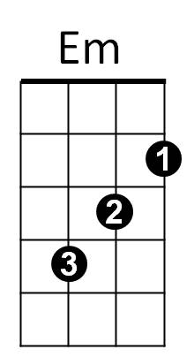Against the wind …. Against the wind **(Repeat to fade)**

**BARITONE**

C

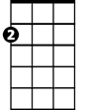

Em



F



G

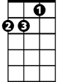

Am

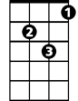

Dm



C

F



Am



G



Dm