**Ain’t We Got Fun (Richard A Whiting / Raymond B Egan) Key C**

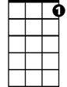

C7



C

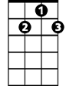

G7

**C G7**

Every morning, every evening, ain’t we got fun?

**C C7**

Not much money, oh but honey, ain’t we got fun?

**F C**

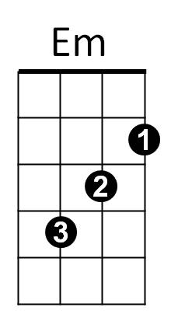The rent’s unpaid, dear, we haven’t a car

E7

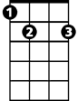

**Em B7 Em G7**

But any-way dear, we’ll stay as we are

**C G7**

Even if we owe the grocer, don’t we have fun?

**C C7**

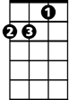

Dm

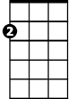

Am

F



Tax collector’s getting closer, still we have fun

**F E7 Am**

There’s nothing sur - er,

**Dm B7 C Fm7**

The rich get richer and the poor get poorer

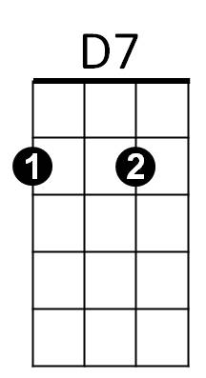**C D7 G7 C**

Fm7

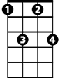

In the meantime, in between time ain’t we got fun?

**(First Verse)**

**C G7**

Even if we owe the grocer, don’t we have fun?

**C C7**

Tax collector’s getting closer, still we have fun

**F E7 Am**

There’s nothing sur - er,

**BARITONE**

**Dm B7 C Fm7**

The rich get richer and the poor get children

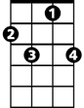

C7



G7

C



**C D9 G7 C**

In the meantime, in between time ain’t we got fun?

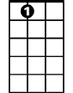

E7



Em

B7



F



Am

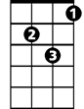

Dm



D7

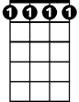

Fm7

**Ain’t We Got Fun (Richard A Whiting / Raymond B Egan) Key F**



F7



C7

F



**F C7**

Every morning, every evening, ain’t we got fun?

**F F7**

Not much money, oh but honey, ain’t we got fun?

**F**

The rent’s unpaid, dear, we haven’t a car



Bb



Am

E7



**Am E7 Am C7**

But any-way dear, we’ll stay as we are

**F C7**

Even if we owe the grocer, don’t we have fun?

**F F7**



Dm



Gm



A7

Tax collector’s getting closer, still we have fun

**Bb A7 Dm**

There’s nothing sur - er,

**Gm E7 F Bbm7**

The rich get richer and the poor get poorer

**F G7 C7 F**



Bbm7



G7

In the meantime, in between time ain’t we got fun?

**(First Verse)**

**F C7**

Even if we owe the grocer, don’t we have fun?

**F F7**

Tax collector’s getting closer, still we have fun

**Bb A7 Dm**

There’s nothing sur - er,

**BARITONE**

**Gm E7 F Bbm7**



F



C7

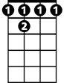

F 7

The rich get richer and the poor get children

**F G7 C7 F**

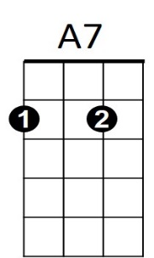In the meantime, in between time ain’t we got fun?

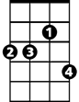

Bbm7



G7



Am



E7

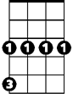

Gm



Dm

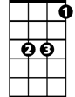

Bb