Alice’s Restaurant – Arlo Guthrie
Key of C Played at Capo II

Introduction & Recitation:  C A7 D7 G7 C  C A7 D7 G7  C C7 F F♯dim  C A7 D7 G7 C | I - VI7 – II7 – V7 – I  I - VI7 – II7 – V7  I – I7 – IV – [Passing Chord of F#dim]  I - VI7 – II7 – V7 – I
Chorus
C A7 D7 G7 C
You can get anything you want at Alice's restaurant
C A7 D7 G7
You can get anything you want at Alice's restaurant
C C7
Walk right in, it's around the back
F F♯dim
Just a half a mile from the railroad track
C A7 D7 G7 C
You can get anything you want at Alice's restaurant

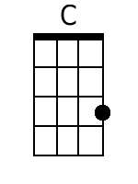  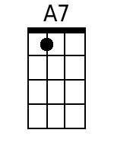  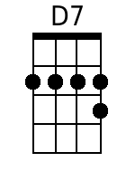  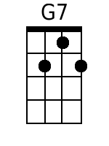 | 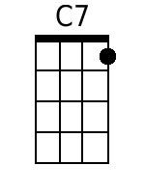  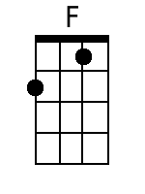  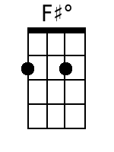

The vii-dim in the Key of C is B♭dim. The F♯dim is only found naturally in the Key of G where it is the vii-dim chord. I suspect that it's use in “Alice's Restaurant” is as a passing chord or a “kinda-sorta” leading-tone seventh chord.
The primary progression itself – I - VI7 - II7 - V7 - I – is a variant of an excerpt from the Circle Progression, I - vi - ii - V - I, where the minor chords are replaced by dominant 7th chords. This is termed the “Ragtime Progression,” although it's use is found in much earlier classical music.

Concerning the Use of the F♯dim Chord

Note:
- The F chord is F A C
- The F♯ chord is F♯ B♭ D♭.

A diminished chord is Root, ♭ 3 and ♭ 5.
- The minor third is up three half-steps from the Root.
- The flat fifth of an F♯ Diminished chord is C. The flat fifth is down six half-steps from the Root -- but it's easier to just think of it as a variation on the fifth. Once you know your fifths, the flat fifth and sharp fifth are a lot easier to find.

Beginning with the F# chord – F♯ B♭ D♭ – the F♯dim Chord is F♯ A C
- Root: F♯
- Minor 3rd: A
- Flatted 5th: C

In “Alice's Restaurant” the bridge progression is C, C7, F, F♯dim, resolving to the C.

Looking at the individual notes, the Progression is:

Chord Name | Root | 3rd | 5th | 7th
C | C | E | G
C7 | C | E | G | B♭
F | F | A | C
F♯dim | F♯ | A | C
C | C | E | G

By looking at this chord progression in a slightly different way – using 2nd inversions of the C and C7 chords – there is an interesting progression in the root position:

Chord Name
C | E | G | C
C7 | E | G | B♭ | C
F | F | A | C
F♯dim | F♯ | A | C
C | G | C | E

