Alice's Restaurant – Barre Chord Progression
Baritone Ukulele
C A7 D7 G7 C
C A7 D7 G7 C
C C7 F F#Dim [the F♯°7th chord looks a lot easier to play]
C A7 D7 G7 C

 |  | 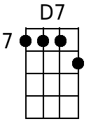 |  | 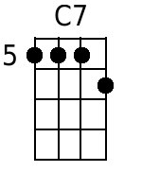
 |  |  | 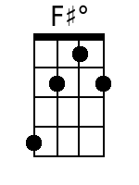  Or: | 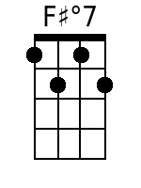

Additional variants

 | 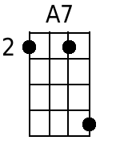  “Hawaiian A7” | 

A7 chord is A C# E G. [Uke “Hawaiian A7”: E G C# E – the A7 chord without the A]
Uke open: D G B E

