All I Have to Do Is Dream (Boudleaux Bryant, 1958) (C)
All I Have To Do Is Dream by The Everly Brothers (E)
Tempo = 96 BPM
Intro: Single strum of C followed by:
C Am F G C Am F G
Dre-eam, dream dream dream; Dre-eam, dream dream dream

C Am F G C Am F G
When I want you __ in my arms, when I want you __ and all your charms
C Am F G C Am F G
When-ever I want you, all I have to do, is dream, dream dream dream

C Am F G C Am F G
When I feel blue __ in the night, and I need you _ to hold me tight
C Am F G C F C C7
When-ever I want you, all I have to do, is Dreeeeam.

Reprise:
F Em Dm G C
I can make you mine, taste your lips of wine, any time, _ night or day
F Em D7 G
Only trouble is, __ gee whiz, I'm dreamin' my life a-way

C Am F G C Am F G
I need you so __ that I could die, I love you so, __ and that is why
C Am F G C Am F G
When-ever I want you, all I have to do, is Dream, dream dream dream,
C F C C7
Dreeeeam Reprise

C Am F G C Am F G
I need you so __ that I could die, I love you so, __ and that is why
C Am F G
When-ever I want you, all I have to do, is
C Am F G
Dre-eam, dream dream dream. (3x; end on G)
 | 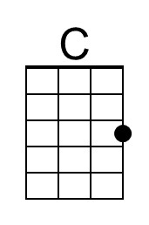 | 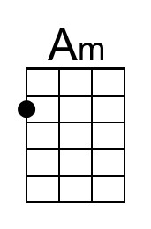 | 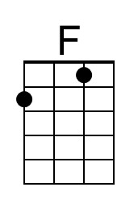 | 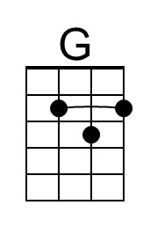 | 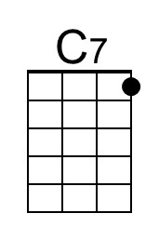 | 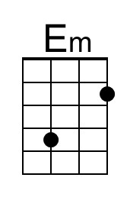 | 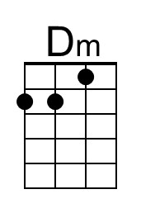 | 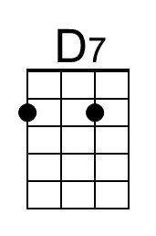
Bari | 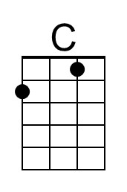 | 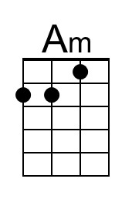 | 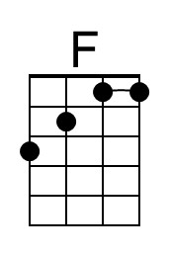 | 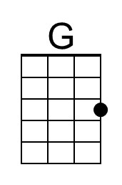 | 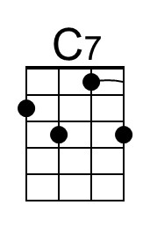 | 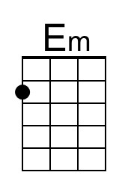 | 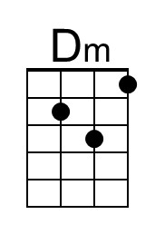 | 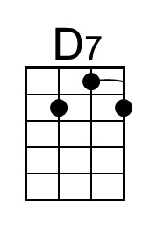

All I Have to Do Is Dream (Boudleaux Bryant, 1958) (F)
All I Have To Do Is Dream by The Everly Brothers (E)
Tempo = 96 BPM
Intro: Single strum of F followed by:
F Dm Bb C F Dm Bb C
Dre-eam, dream dream dream; Dre-eam, dream dream dream

F Dm Bb C F Dm Bb C
When I want you __ in my arms, when I want you __ and all your charms
F Dm Bb C F Dm Bb C
When-ever I want you, all I have to do, is dream, dream dream dream

F Dm Bb C F Dm Bb C
When I feel blue in the night, and I need you _ to hold me tight
F Dm Bb C F Bb F F7
When-ever I want you, all I have to do, is Dreeeeam.

Reprise
Bb Am Gm C F
I can make you mine, taste your lips of wine, any time, _ night or day
Bb Am G7 C
Only trouble is, __ gee whiz, I'm dreamin' my life a-way.

F Dm Bb C F Dm Bb C
I need you so __ that I could die, I love you so, __ and that is why
F Dm Bb C F Dm Bb C
When-ever I want you, all I have to do, is Dream, dream dream dream,
F Bb F F7
Dreeeeam. Reprise

F Dm Bb C F Dm Bb C
I need you so __ that I could die, I love you so, __ and that is why
F Dm Bb C
When-ever I want you, all I have to do, is
F Dm Bb C
Dre-eam, dream dream dream. (3x; end on F)
 |  |  | 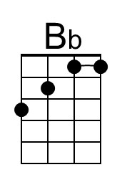 |  | 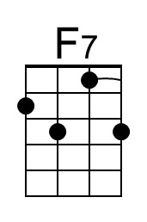 |  | 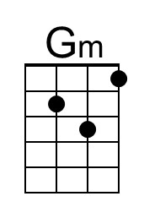 | 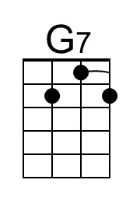
Bari |  |  | 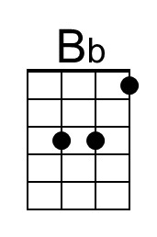 |  | 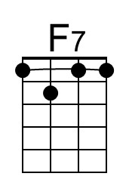 |  | 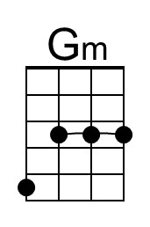 | 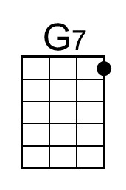

All I Have to Do Is Dream (Boudleaux Bryant, 1958) (G)
All I Have To Do Is Dream by The Everly Brothers (E)
Tempo = 96 BPM
Intro: Single strum of G followed by:
G Em C D G Em C D
Dre-eam, dream dream dream; Dre-eam, dream dream dream

G Em C D G Em C D
When I want you __ in my arms, when I want you __ and all your charms
G Em C D G Em C D
Whenever I want you, all I have to do, is dream, dream dream dream

G Em C D G Em C D
When I feel blue __ in the night, and I need you _ to hold me tight
G Em C D G C G G7
Whenever I want you, all I have to do, is Dreeeeam.

Reprise:
C Bm Am D G
I can make you mine, taste your lips of wine, any time, _ night or day
C Bm A7 D
Only trouble is, __ gee whiz, I'm dreamin' my life a-way

G Em C D G Em C D
I need you so __ that I could die, I love you so, __ and that is why
G Em C D G Em C D
When-ever I want you, all I have to do, is Dream, dream dream dream,
G C G G7
Dreeeeam Reprise

G Em C D G Em C D
I need you so __ that I could die, I love you so, __ and that is why
G Em C D
When-ever I want you, all I have to do, is
G Em C D
Dre-eam, dream dream dream. (3x; end on C)
 |  |  |  |  |  | 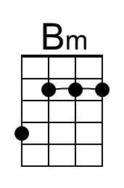 |  | 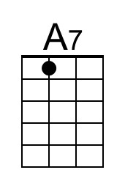
Bari |  |  |  |  |  | 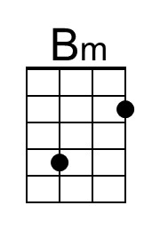 |  | 