All I Have to Do Is Dream (Boudleaux Bryant, 1958) (G)

G Em C D G Em C D
Dre-eam, dream dream dream; Dre-eam, dream dream dream

G Em C D G Em C D
When I want you in my arms, when I want you and all your charms
G Em C D G Em C D
Whenever I want you, all I have to do, is dream, dream dream dream

G Em C D G Em C D
When I feel blue in the night, and I need you _ to hold me tight
G Em C D G C G G7
Whenever I want you, all I have to do, is Dreeeeam.

Reprise
C Bm Am D G
I can make you mine, taste your lips of wine, any time, _ night or day
C Bm A7 D
Only trouble is, gee whiz, I'm dreamin' my life a-way

G Em C D G Em C D
I need you so that I could die, I love you so, and that is why
G Em C D G Em C D
Whenever I want you, all I have to do, is Dream, dream dream dream,
G C G G7
Dreeeeam Reprise

G Em C D G Em C D
I need you so that I could die, I love you so, and that is why
G Em C D
When-ever I want you, all I have to do, is
G Em C D
Dre-eam, dream dream dream. (Repeat line 3x to fade; end on C)

 | 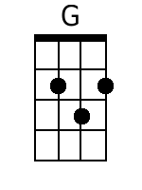 | 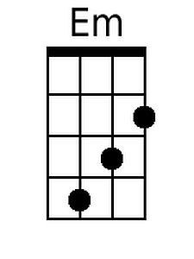 | 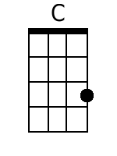 | 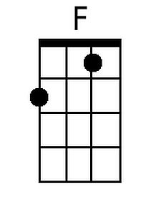 | 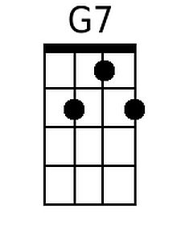 | 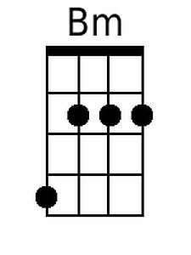 | 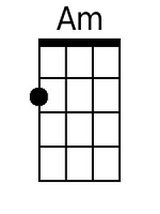 | 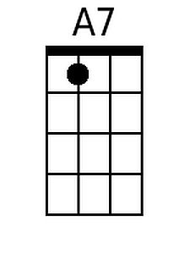
Bari | 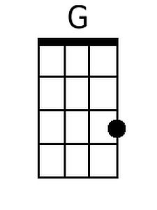 | 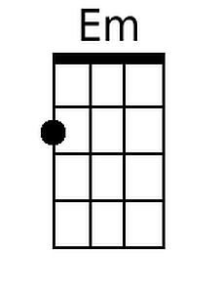 | 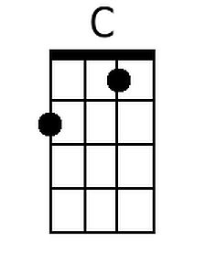 | 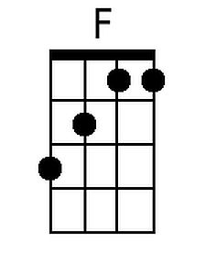 | 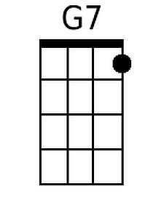 | 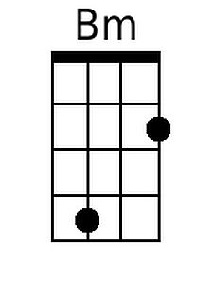 | 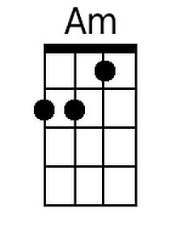 | 