**All I Have to Do Is Dream (Roy Orbison)**

**C Am F G**

Dre-eam, dream dream dream

**C Am F G**

Dre-eam, dream dream dream

**C Am F G**

When I want you in my arms,

**C Am F G**

When I want you and all your charms

**C Am F G**

Whenever I want you, all I have to do, is

**C Am F G**

Dream, dream dream dream

**C Am F G**

When I feel blue in the night,

**C Am F G**

And I need you to hold me tight

**C Am F G**

Whenever I want you, all I have to do, is

**C F C C7**

Dreeeeam

**Reprise:**

**F**

I can make you mine,

**Em**

Taste your lips of wine,

**Dm G C**

Any time, night or day

**F Em**

Only trouble is, gee whiz,

**D7 G**

I'm dreamin' my life away

**BARITONE**

C



F



G

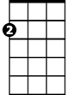

Em

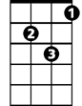

Dm

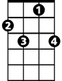

C7

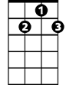

D7

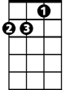

Am

**C Am F G**

I need you so that I could die,

**C Am F G**

I love you so, and that is why

**C Am F G**

Whenever I want you, all I have to do, is

**C Am F G**

Dream, dream dream dream,

**C F C C7**

Dreeeeam

**(Reprise)**

**C Am F G**

I need you so that I could die,

**C Am F G**

I love you so, and that is why

**C Am F G**

Whenever I want you, all I have to do, is

**(repeat 3x to fade)**

**C Am F G**

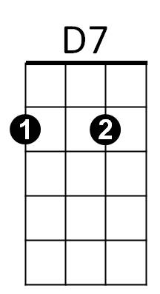Dre-eam, dream dream dream,



G

F



Am



C

Em

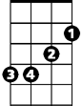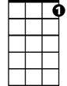

C7



Dm