**All My Exes Live in Texas** (**Sanger D. Shafer / Linda J. Shafer)**

**Chorus**

**G D**

All my exes live in Texas

**D7 Am G**

And Texas is the place I’d dearly love to be

**D**

But all my exes live in Texas

**D7 G**

And that’s why I hang my hat in Tennessee

**G**

Rosanna’s down in Texarkana,

**Am**

Wanted me to push her broom

**D**

Sweet Eileen’s in Abilene,

**G**

She forgot I hung the moon

And Allison’s in Galveston,

**Am**

somehow lost her sanity

**A7**

And Dimples, who now lives in Temple,

**D**

Has got the law looking for me

**(Chorus)**

**G Am**

I remember that ol’ Frio River where I learned to swim

**D**

But it brings to mind another time

**G**

Where I wore my welcome thin

**Am**

By Transcendental Meditation I go there each night

**A7 D**

But I always come back to myself, long before daylight

**G D**

All my exes live in Texas

**D7 Am G**

And Texas is the place I’d dearly love to be

**D**

But all my exes live in Texas

**D7 G**

Therefore I reside in Tennessee

**D**

Some folks think I’m hidin’ ~

it’s been rumored that I died

**D7 G**

But I’m alive and well in Tennessee

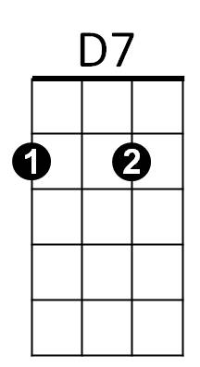

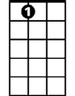

A7



G

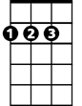

D

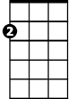

Am

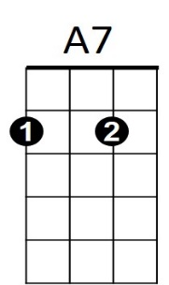



G



D

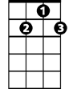

D7

**BARITONE**

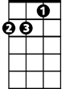

Am