All My Loving (Paul McCartney & John Lennon, 1963) (Am)

Am D7  1. Close your eyes and I’ll kiss you,  G Em  Tomorrow I’ll miss you  C Am F D7  Remember I’ll always be true.  Chorus  Am D7  And then while I’m a-way,  G Em  I’ll write home every day  C D7 G  And I’ll send all my loving to you.  Am D7  2. I’ll pre-tend that I’m kissing  G Em  The lips I am missing,  C Am F D7  And hope that my dreams will come true. Chorus  Bridge  Em G  All my loving, I will send to you.  Em G  All my loving. Darling I’ll be true.  Repeat Verse 1. Repeat Chorus. Repeat Bridge.  Outro  Em G  All my loving . . . All my loving, OOoooo  Em G  All my loving, I will send to you. |  |  |  |  |  |  |  |  | 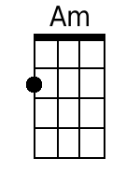
 |  |  |  |  |  |  |  |  | 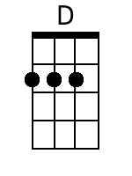
 |  |  |  |  |  |  |  |  | 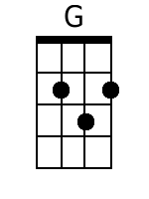
 |  |  |  |  |  |  |  |  | 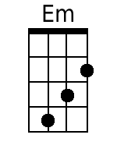
 |  |  |  |  |  |  |  |  | 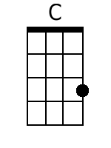
 |  |  |  |  |  |  |  |  | 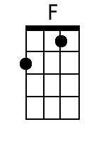
Bari | 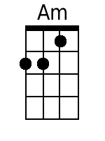 | 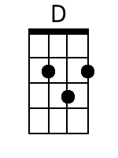 | 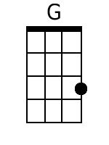 | 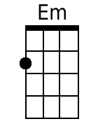 | 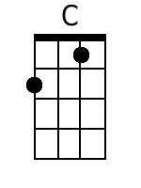 | 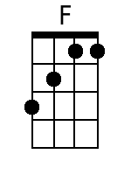

All My Loving (Paul McCartney & John Lennon, 1963) (Dm)

Dm G7  1. Close your eyes and I'll kiss you,  C Am  Tomorrow I'll miss you  F Dm Bb G7  Remember I'll always be true.  Chorus  Dm G7  And then while I'm a-way,  C Am  I'll write home every day  F G7 C  And I'll send all my loving to you.  Dm G7  2. I'll pre-tend that I'm kissing  C Am  The lips I am missing,  F Dm Bb G7  And hope that my dreams will come true. Chorus  Bridge  Am C  All my loving, I will send to you.  Am C  All my loving. Darling I'll be true.  Repeat Verse 1. Repeat Chorus. Repeat Bridge.  Outro  Am C  All my loving . . . All my loving, OOoooo  Am C  All my loving, I will send to you. |  |  |  |  |  |  |  |  | 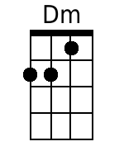
 |  |  |  |  |  |  |  |  | 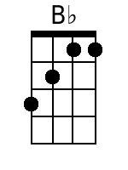
Bari | 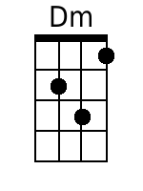 |  |  |  |  | 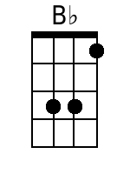

All My Loving (Paul McCartney & John Lennon, 1963) (Em)

Em A7
1. Close your eyes and I'll kiss you,
D Bm
Tomorrow I'll miss you
G Em C A7
Remember I'll always be true.

Chorus
Em A7
And then while I'm a-way,
D Bm
I'll write home every day
G A7 D
And I'll send all my loving to you.

Em A7
2. I'll pre-tend that I'm kissing
D Bm
The lips I am missing,
G Em C A7
And hope that my dreams will come true. Chorus

Bridge
Bm D
All my loving, I will send to you.
Bm D
All my loving. Darling I'll be true.

Repeat Verse 1. Repeat Chorus. Repeat Bridge.

Outro
Bm D
All my loving . . . All my loving, OOoooo
Bm D
All my loving, I will send to you.

 |  |  |  |  |  |  |  |  | 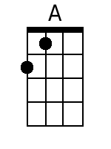
 |  |  |  |  |  |  |  |  | 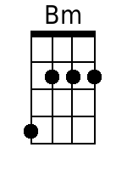
Bari |  | 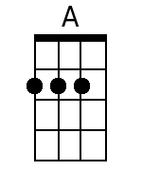 |  | 