
All of Me (Seymore Simons and Gerald Marks, 1931)
All of Me by Frank Sinatra – Key of G

Intro C  C E7  All of me, why not take all of me?  A7 Dm  Can't you see that I'm no good with-out you?  E7 Am  Take my lips, I want to lose them,  D7 G7  Take my arms, I'll never use them.  C E7  Your goodbye, left me with eyes that cry.  A7 Dm  How can I go on dear with-out you?  Fm C A7  You took the part that once was my heart  Dm7 G7 C G7  So why not take all of me.  C E7  All of me, come on, take all of me  A7 Dm  Can't you see I'm just a mess with-out you  E7 Am  Take my lips, I want to lose them,  D7 G7  Get a piece of these arms, I'll never use them.  C E7  Your goodbye, left me with eyes that cry.  A7 Dm  How can I, ever make it with-out you?  Fm C A7  You know, you got the part that used to be my heart  Fm G7 C Am  So why not, why not take all of me.  Fm G7 C  So why not, why not take all of me. | 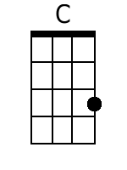 | 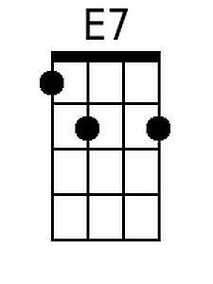 | 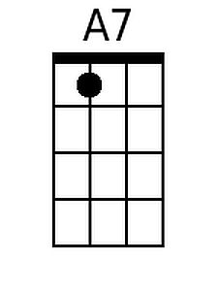
 | 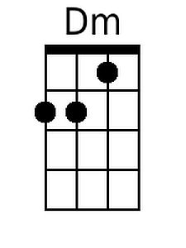 | 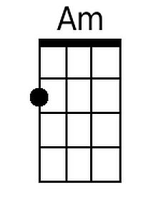 | 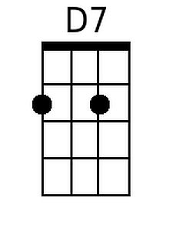
 | 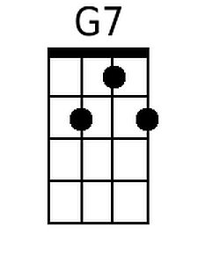 | 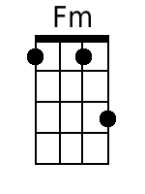
 | Bari
 | 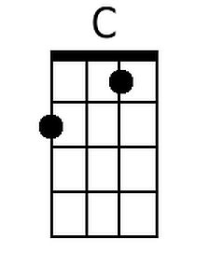 | 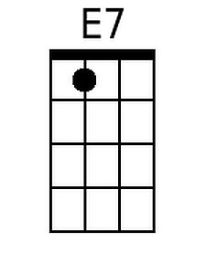 | 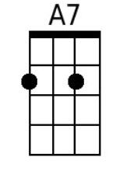
 | 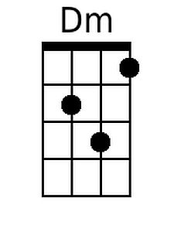 | 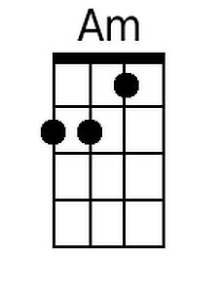 | 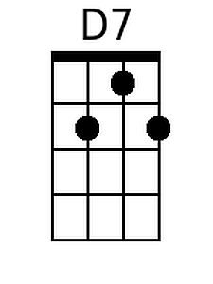
 | 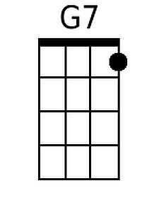 | 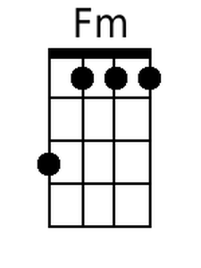

All of Me (Seymore Simons and Gerald Marks, 1931)
All of Me by Frank Sinatra – Key of G

Intro G  G B7  All of me, why not take all of me?  E7 Am  Can't you see that I'm no good with-out you?  B7 Em  Take my lips, I want to lose them,  A7 D7  Take my arms, I'll never use them.  G B7  Your goodbye, left me with eyes that cry.  E7 Am  How can I go on dear with-out you?  Cm G E7  You took the part that once was my heart  Am7 D7 G D7  So why not take all of me.  G B7  All of me, come on, take all of me  E7 Am  Can't you see I'm just a mess with-out you  B7 Em  Take my lips, I want to lose them,  A7 D7  Get a piece of these arms, I'll never use them.  G B7  Your goodbye, left me with eyes that cry.  E7 Am  How can I, ever make it with-out you?  Cm G E7  You know, you got the part that used to be my heart  Cm D7 G Em  So why not, why not take all of me.  Cm D7 G  So why not, why not take all of me. | 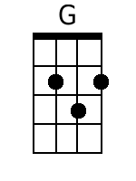 | 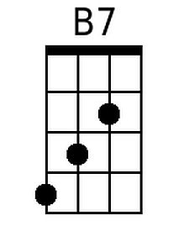
 | 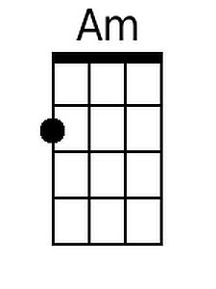 | 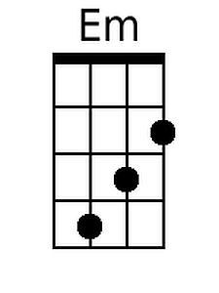
 |  | 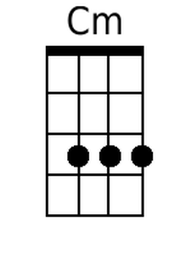
 | Bari
 | 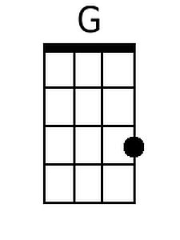 | 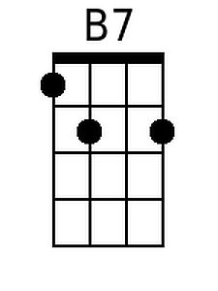
 |  | 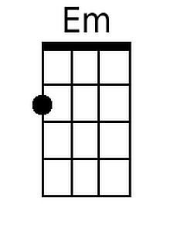
 |  | 