All of Me (Seymore Simons and Gerald Marks, 1931)
All of Me by Willie Nelson – Key of C

Intro C Gº7 Dm7 G7  C E7  All of me, why not take all of me  A7 Dm  Can't you see that I'm no good with out you  E7 Am  Take my arms, I wanna lose them.  D7 Dm7 G7  Take my lips, I’ll never use them.  C E7  Your goodbye, left me with eyes that cry.  A7 Dm  And I know that I am no good with-out you.  F Fm C Em7 A7  You took the part that once was my heart  Dm7 G7 C Gº7 Dm7 G7  So why not take all of me?  Instrumental Verses  Repeat Verses  Outro:  Dm7 G7 C Gº7 Dm7 G7 C  Why not take all of me?  Instrumental Verses |  |  |  |  |  |  | 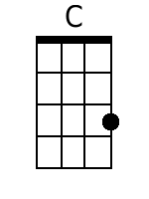 | 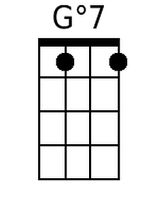
 |  |  |  |  |  |  | 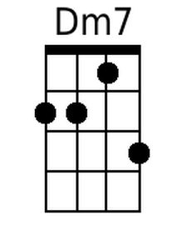 | 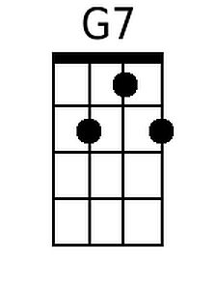
 |  |  |  |  |  |  | 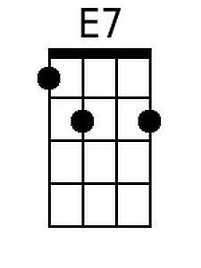 | 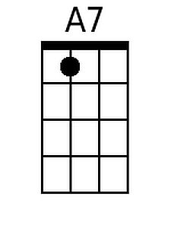
 |  |  |  |  |  |  | 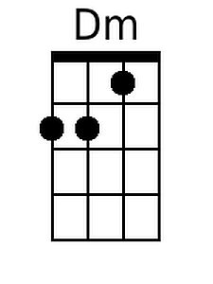 | 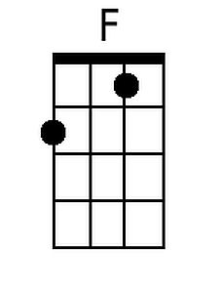
 |  |  |  |  |  |  | 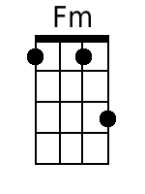 | 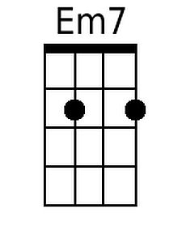
 |  |  | Bari | 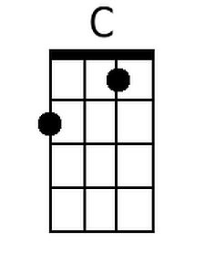 | 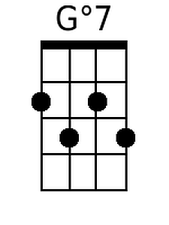 | 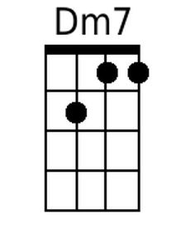 | 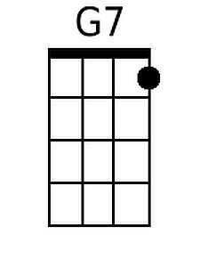 | 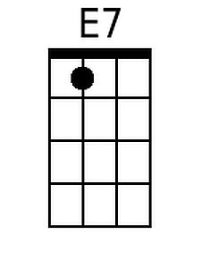
 |  |  |  | 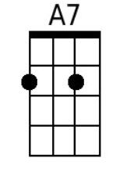 | 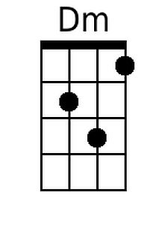 | 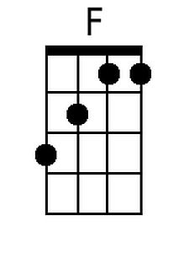 | 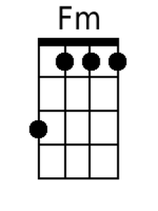 | 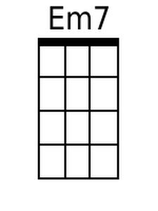

All of Me (Seymore Simons and Gerald Marks, 1931)
All of Me by Willie Nelson – Key of G

Intro G Dº7 Am7 D7  G B7  All of me, why not take all of me  E7 Am  Can't you see that I'm no good with out you  B7 Em  Take my arms, I wanna lose them.  A7 Am7 D7  Take my lips, I'll never use them.  G B7  Your goodbye, left me with eyes that cry.  E7 Am  And I know that I am no good with-out you.  C Cm G Bm7 E7  You took the part that once was my heart  Am7 D7 G Dº7 Am7 D7  So why not take all of me?  Instrumental Verses  Repeat Verses  Outro:  Am7 D7 G Dº7 Am7 D7 G  Why not take all of me?  Instrumental Verses |  |  |  |  |  |  | 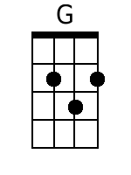 | 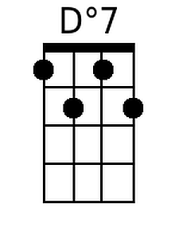
 |  |  |  |  |  |  | 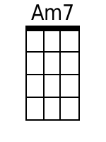 | 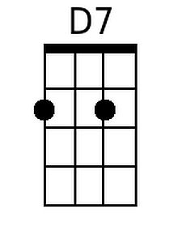
 |  |  |  |  |  |  | 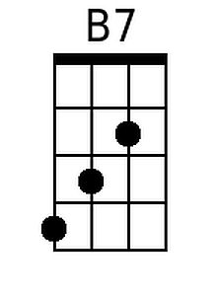
 |  |  |  |  |  |  | 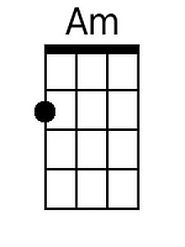
 |  |  |  |  |  |  | 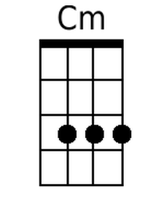 | 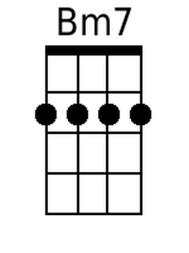
 |  |  | Bari | 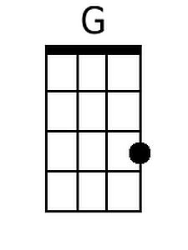 | 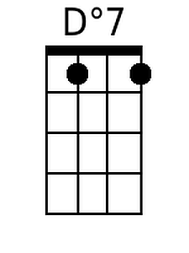 | 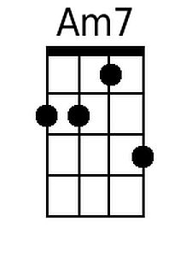 | 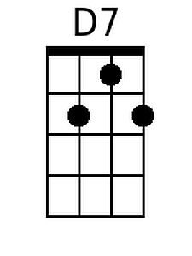 | 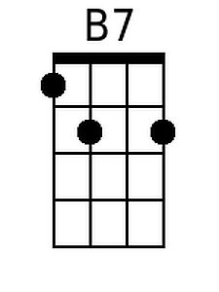
 |  |  |  |  | 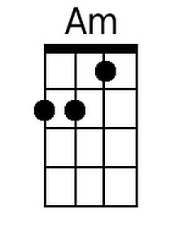 |  | 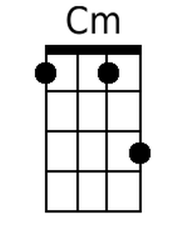 | 