**Always Look on the Bright Side of Life (Eric Idle)**

**Am Adim**

Some things in life are bad,

**G Em7**

They can really make you mad

**Am Adim G Em7**

Other things just make you swear and curse

**Am Adim**

When you're chewing on life's gristle

**G E7**

Don't grumble, give a whistle

**A7 D7**

And this'll help things turn out for the best

**Chorus:**

**G Em7 Am D7 G**

And always look on the bright side of life

**Em7 Am D7**

**G Em7 Am D7 G Em7 Am D7**

Always look on the light side of life

**Am Adim**

If life seems jolly rotten,

**G Em7**

There's some thing you've forgotten

**Am Adim**

And that's to laugh and smile

**G Em7**

And dance and sing.

**Am Adim**

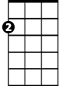

Am

When you're feeling in the dumps,

**G E7**

Don't be silly chumps

**A7 D7**

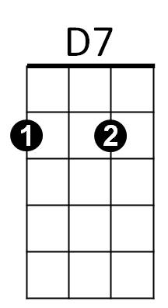Just purse your lips and whistle - that's the thing

**(Chorus)**

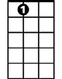

A7

**Am Adim G Em7**

For life is quite absurd and death's the final word

**Am Adim G Em7**

You must always face the curtain with a bow

**Am Adim G Em7**

Forget about your sin - give the audience a grin

**A7 D7**

**BARITONE**



D

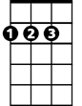

A

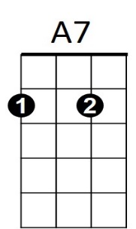Enjoy it - it's your last chance anyhow.

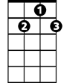

D7

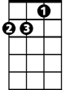

Am



E7

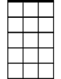

Em7



G

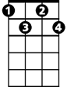

Adim

**G Em7 Am D7 G**

So always look on the bright side of death

**Em7 Am D7**

**G Em7 Am D7 G**

Just before you draw your terminal breath

**Em7 Am D7**

**Am Adim G Em7**

Life's a piece of s - t when you look at it

**Am Adim G Em7**

Life's a laugh and death's a joke, it's true

**Am Adim**

You'll see it's all a show,

**G E7**

keep 'em laughing as you go

**A7 D7**

Just remember that the last laugh is on you

**G Em7 Am D7 G**

And always look on the bright side of life

**Em7 Am D7**

**G Em7 Am D7 G Em7 Am D7**

Always look on the right side of life

(Come on guys, cheer up)

**A D Bm E7 A D Bm E7**

Always look on the bright side of life

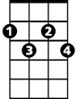

Adim

**A D Bm E7 A D Bm E7**

Always look on the right side of life



D

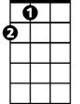

A

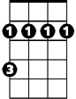

Bm

Bm

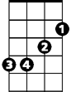

E7

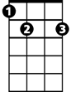

Em7

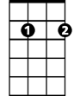

G