Always Look on the Bright Side of Life (Eric Idle)

Am Adim
Some things in life are bad,
G Em7
They can really make you mad
Am Adim G Em7
Other things just make you swear and curse
Am Adim
When you're chewing on life's gristle
G E7
Don't grumble, give a whistle
A7 D7
And this'll help things turn out for the best

Chorus:
G Em7 Am D7 G
And always look on the bright side of life
Em7 Am D7
G Em7 Am D7 G Em7 Am D7
Always look on the light side of life

Am Adim
If life seems jolly rotten,
G Em7
There's some thing you've forgotten
Am Adim
And that's to laugh and smile
G Em7
And dance and sing.
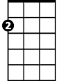
Am Adim
Am
When you're feeling in the dumps,
G E7
Don't be silly chumps
A7 D7
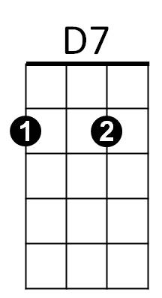
Just purse your lips and whistle - that's the thing
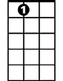
(Chorus)
A7
Am Adim G Em7
For life is quite absurd and death's the final word
Am Adim G Em7
You must always face the curtain with a bow
Am Adim G Em7
Forget about your sin - give the audience a grin

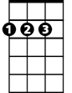
A7 D7
BARITONE
D
A
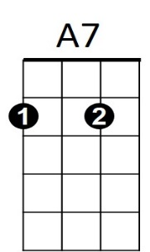
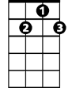
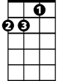
Enjoy it - it's your last chance anyhow.
D7
Am
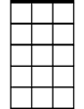

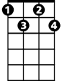
E7
Em7
G
Adim

G Em7 Am D7 G
So always look on the bright side of death
Em7 Am D7
G Em7 Am D7 G
Just before you draw your terminal breath
Em7 Am D7

Am Adim G Em7
Life's a piece of s - t when you look at it
Am Adim G Em7
Life's a laugh and death's a joke, it's true
Am Adim
You'll see it's all a show,
G E7
keep 'em laughing as you go
A7 D7
Just remember that the last laugh is on you

G Em7 Am D7 G
And always look on the bright side of life
Em7 Am D7
G Em7 Am D7 G Em7 Am D7
Always look on the right side of life
(Come on guys, cheer up)
A D Bm E7 A D Bm E7
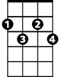
Always look on the bright side of life
Adim
A D Bm E7 A D Bm E7
Always look on the right side of life
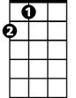
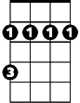
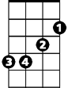
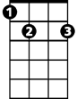
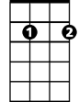
D
A
Bm
Bm
E7
Em7
G

