**Always on My Mind (James Mark / Christopher John Lee Jr) Key of C**

**C G**

Maybe I didn't love you~~

**Am C F** **G C**

Quite as often as I could have

**G**

And maybe I didn't treat you~~

**Am C Dm7 F**

Quite as good as I should have ~~

**F C**

If I made you feel second best,

**F C Dm G**

Girl, I'm sorry I was blind ~~

**Am G7 C** **Dm Em F**

But you were always on my mind

**G7 C** **F G**

You were always on my mind

**C G**

Maybe I didn't hold you~~

**Am C F** **G C**

All those lonely, lonely times

**G**

And I guess I never told you~~

**Am C Dm7 F**

I'm so happy that you're mine ~~

**F C F**

Little things I should have said and done

**C Dm F G**

I just never took the time

**G7 C F**

You were always on my mind~~

**G7 C F G**

You were always on my mind

**C G Am C**

Tell me,

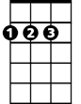

A

Bm

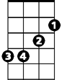

D

**F C Dm**

Tell me that your sweet love hasn't died

**C G Am C**

Give me,

**F C Dm G**

Give me one more chance to keep you satisfied

**C G**

*Maybe I didn't hold you~~*

**Am C F** **G C**

*All those lonely, lonely times*

**G**

*And I guess I never told you~~*

**Am C Dm7 F**

*I'm so happy that you're mine ~~*

**F C**

Little things I should have said and done

**F C Dm F G**

I just never took the time

**G7 C F**

You were always on my mind~~

**G7 C F G**

You were always on my mind

**Am G7 C Dm Em F**

But you were always on my mind

**G7 C F C**

You were always on my mind

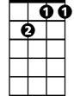

Dm7

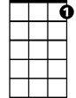

G7

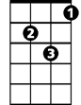

Dm

C



G

**BARITONE**



F

Em

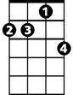

Dm7

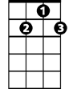

G7

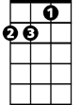

Dm



C



G

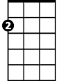

Am

F



Am



Em

**Always on My Mind (James Mark / Christopher John Lee Jr) Key of D**

**D A**

Maybe I didn't love you~~

**Bm D G** **A D**

Quite as often as I could have

**A**

And maybe I didn't treat you~~

**Bm D Em7 G**

Quite as good as I should have ~~

**G D**

If I made you feel second best,

**G D Em A**

Girl, I'm sorry I was blind ~~

**Bm A7 D** **Em F#m G**

But you were always on my mind

**A7 D** **G A**

You were always on my mind

**D A**

Maybe I didn't hold you~~

**Bm D G** **A D**

All those lonely, lonely times

**A**

And I guess I never told you~~

**Bm D Em7 G**

I'm so happy that you're mine ~~

**G D G**

Little things I should have said and done

**D Em G A**

I just never took the time

**A7 D G**

You were always on my mind~~

**A7 D G A**

You were always on my mind

**D A Bm D**

Tell me,

**G D Em**

Tell me that your sweet love hasn't died

**D A Bm D**

Give me,

**G D Em A**

Give me one more chance to keep you satisfied

**D A**

*Maybe I didn't hold you~~*

**Bm D G** **A D**

*All those lonely, lonely times*

**A**

*And I guess I never told you~~*

**Bm D Em7 G**

*I'm so happy that you're mine ~~*

**G D G**

Little things I should have said and done

**D Em G A**

I just never took the time

**A7 D G**

You were always on my mind~~

**A7 D G A**

You were always on my mind

**Bm A7 D Em F#m G**

But you were always on my mind

**A7 D G D**

You were always on my mind



G

**BARITONE**

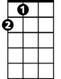

A



D

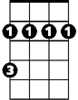

Bm

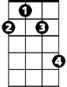

F#m

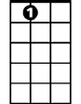

A7

Em7

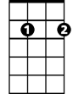

Em



A

Bm



G



D

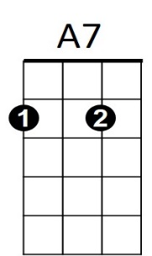

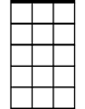

Em7



F#m



Em

**Always on My Mind (James Mark / Christopher John Lee Jr) Key of G**

**G D**

Maybe I didn't love you~~

**Em G C** **D G**

Quite as often as I could have

**D**

And maybe I didn't treat you~~

**Em G Am7 C**

Quite as good as I should have ~~

**C G**

If I made you feel second best,

**C G Am D**

Girl, I'm sorry I was blind ~~

**Em D7 G** **Am Bm C**

But you were always on my mind

**D7 G** **C D**

You were always on my mind

**G D**

Maybe I didn't hold you~~

**Em G C** **D G**

All those lonely, lonely times

**D**

And I guess I never told you~~

**Em G Am7 C**

I'm so happy that you're mine ~~

**C G C**

Little things I should have said and done

**G Am C D**

I just never took the time

**D7 G C**

You were always on my mind~~

**D7 G C D**

You were always on my mind

**G D Em G**

Tell me,

**C G Am**

Tell me that your sweet love hasn't died

**G D Em G**

Give me,

**C G Am D**

Give me one more chance to keep you satisfied

**G D**

*Maybe I didn't hold you~~*

**Em G C** **D G**

*All those lonely, lonely times*

**D**

*And I guess I never told you~~*

**Em G Am7 C**

*I'm so happy that you're mine ~~*

**C G C**

Little things I should have said and done

**G Am C D**

I just never took the time

**D7 G C**

You were always on my mind~~

**D7 G C D**

You were always on my mind

**Em D7 G Am Bm C**

But you were always on my mind

**D7 G C G**

You were always on my mind



C

Em



D



G

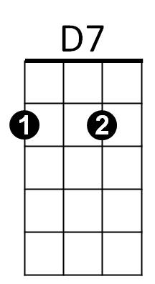



Am



Bm



Am7

**BARITONE**

C



Em



G



D



Am7



D7



Am

Bm

