**America the Beautiful (Katharine Lee Bates / Samuel A. Ward) (1911 lyrics)**

**C G**



C

O beautiful for spacious skies,

**G7 C**

For amber waves of grain,

**G**

For purple mountain majesties

**D D7 G G7**



G

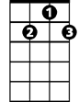

G7

Above the fruited plain!

**C G**

America! America!

**G7 C**

God shed His grace on thee

**F C**

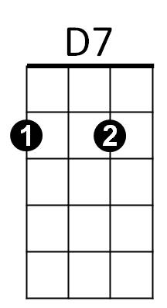And crown thy good with brotherhood

F

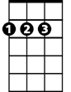

D

**F G7 C**

From sea to shining sea!

**C G**

O beautiful for pilgrim feet,

**G7 C**

Whose stern, impassioned stress

**G**

A thoroughfare for freedom beat

**D D7 G G7**

Across the wilderness!

**C G**

America! America!

**G7 C**

God mend thine every flaw,

**F C**

Confirm thy soul in self-control,

**F G7 C**

Thy liber-ty in law!

**BARITONE**



D

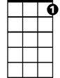

G7



G

C



D7

**C G**

O beautiful for heroes proved

**G7 C**

In liber-ating strife,

**G**

Who more than self their country loved

**D D7 G G7**

And mercy more than life!

**C G**

America! America!

**G7 C**

May God thy gold refine,

**F C**

Till all success be nobleness,

**F G7 C**

And every gain divine!

**C G**

O beautiful for patriot dream

**G7 C**

That sees beyond the years

**G**

Thine alabaster cities gleam

**D D7 G G7**

Undimmed by human tears!

**C G**

America! America!

**G7 C**

God shed His grace on thee

**F C**

And crown thy good with brotherhood

**F G7 C**

From sea to shining sea!



F

**America the Beautiful (Katharine Lee Bates / Samuel A. Ward) (1911 lyrics)**

**G D**



G

O beautiful for spacious skies,

**D7 G**

For amber waves of grain,

**D**

For purple mountain majesties



D

**A A7 D D7**

Above the fruited plain!

**G D**

America! America!

**D7 G**

God shed His grace on thee

**C G**

And crown thy good with brotherhood

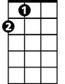

A

**C D7 G**

From sea to shining sea!

**G D**

O beautiful for pilgrim feet,

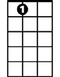

A7

**D7 G**

Whose stern, impassioned stress

**D**

A thoroughfare for freedom beat

**A A7 D D7**

Across the wilderness!

**G D**



C

America! America!

**D7 G**

God mend thine every flaw,

**C G**

Confirm thy soul in self-control,

**C D7 G**

Thy liber-ty in law!

**BARITONE**

**G D**

O beautiful for heroes proved

**D7 G**

In liber-ating strife,

**D**

Who more than self their country loved

**A A7 D D7**

And mercy more than life!

**G D**

America! America!

**D7 G**

May God thy gold refine,

**C G**

Till all success be nobleness,

**C D7 G**

And every gain divine!

**G D**

O beautiful for patriot dream

**D7 G**

That sees beyond the years

**D**

Thine alabaster cities gleam

**A A7 D D7**

Undimmed by human tears!

**G D**

America! America!

**D7 G**

God shed His grace on thee

**C G**

And crown thy good with brotherhood

**C D7 G**

From sea to shining sea!

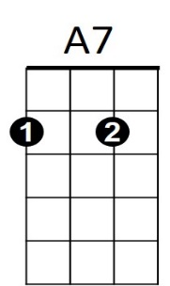

C



D7



D



G



A