**American Tune (Paul Simon)**

**C F C G7 C G C Am E7 Am**



G



C

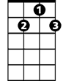

G7

F



Many's the time I've been mis-ta-ken and many times confused

**C F C G7 C G C Am E7 Am C7**

Yes and I've of - ten felt for-sa-ken and certainly misused

**F G F C F C G Am A7**

Aw, but I'm all right, I'm all right, I'm just weary to my bones

**D7 G7 C G7 D G**

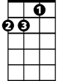

Dm

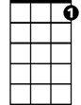

C7

E7

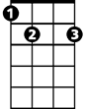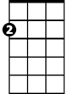

Am

Still you don't expect to be bright and bon vivant

**F C G E7 Am Dm C G C**

So far away from home, so far away from home

**C F C G7 C G E7**

And I don't know a soul who's not been ba t-tered

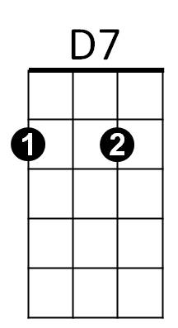 **Am E7 Am**

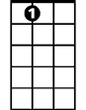

A7

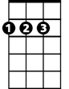

D

I don't have a friend that feels at ease

**C F C G7 C G C Am E7 Am C7**

I don't know a dream that's not been shattered or driven to its knees

**F G F C F C G Am A7**

Aw, but it's all right, it's all right for we lived so well so long

**D7 G7 C G7 D G**

Still when I think of the road we're travelin' on

**F C G E7 Am**

I wonder what's gone wrong,

**Dm C G C**

**BARITONE**

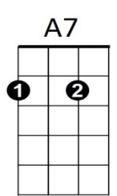I can't help but wonder what's gone wrong

C



G



F



G7



Am



Em

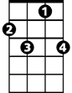

C7

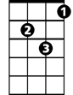

Dm



D7



D

**C**

And I dreamed I was dying...

**G G7 Am**

I dreamed that my soul rose unexpectedly

**G7 F C G G7**

And looking back down on me smiled reassuringly

**C**

And I dreamed I was flying....

**G G7 Am**

And high up above my eyes could clearly see

**G7 C G G7**

The Statue of Liberty - sailing away to sea

**C**

And I dreamed I was flying....

**C F C G C G E7**

For we come on the ship they call the Mayflower

**Am E7 Am**

We come on the ship that sailed the moon

**C F C G C G C**

We come in the age’s most un - certain hours

**Am E7 Am C7**

And sing an American Tune

**F G F C F C G Am A7**

Aw, but it's all right, it's alright it’s alright you can't be for – ever blessed

**D7 G C G7 D G**

Still tomorrow's gonna be a - nother working day

**C F C G E7 Am Dm C G G7 C G C F G7 C**

And I'm trying to get some rest, that's all I'm trying to get some rest