**Amie (Travis Tritt)**

**Intro: G C**

**G C**

Fallin' in and out of love with you

**G C**

Fallin' in and out of love with you

**G C**

Don't know what I'm gonna do, ‘cause I keep -

**G C Bb D7**

Fallin' in and out of love.

**G F C / G F C**

**G F G**

I can see why you think you belong to me

**C G**

I never tried to make you think or let you see one thing

**C**

for yourself

**Bb C**

But now you're off with someone else and I'm alone

**Bb D**

You see I thought that I might keep you for my own.

**Chorus:**

**G F C G**

Amie, what you wanna do

**F C**

I think I could stay with you

**Am D**

For a while, maybe longer, if I knew.

**G F C / G F C**

**G F G**

Don't you think the time is right for us to find

**C G**

All the things we thought weren't proper could be right in time

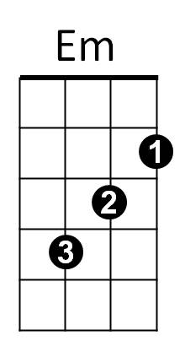 **C Bb**

And can't you see, which way we should turn together

**C**

or alone

**Bb D**

I can't ever see what's right or what is, wrong

(It'll take too long, you see)

**(Chorus)**

**BARITONE**

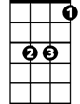

Bb



G

C



D

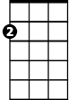

Em



F

**(Instrumental verse)**

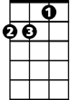

Am

**(Chorus) G F C**

**G F G**

Now it's come to what you want, you've had it your way

**C G**

And all the things you thought before just faded into gray

**C**

and can't you see

**Bb C**

That I don't know if it's you or if it's me

**Bb D**

If it's one of us I'm sure we both will, see

(Won't you look at me and tell me)

**G F C G**

Amie, what you wanna do

**F C**

I think I could stay with you

**Am D**

For a while, maybe longer - longer if I do, yeah now…

**(Chorus)**

**G C**

‘Cause I keep…Fallin' in and out of love with you

**G C**

Fallin' in and out of love with you

**G C**

Don't know what I'm gonna do

**G C Bb D G**

Cause I keep, fallin' in and out of love with you-u-u.



G



Bb



C

F

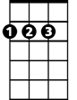

D



Am