Auld Lang Syne (C)
Updated Lyrics based on the Robert Burns poems by Doug Anderson
Tune: “Auld Lang Syne”

Intro (Last line of verse) F G7 C G7  C G7 F G7  Should our old friendships be for-got  C C7 F  And banished from the mind?  C G7 F G7  No, my old friends are like pure gold,  F G7 C - G7  Sin Auld Lang Syne.  Chorus  C G7  For those old times, my friend,  C C7 F  For those old days.  C G7 F E7  We'll take a cup and warmly toast  F G7 C - G7  For auld lang syne.  Outro:  C G7  For auld lang syne, my friend,  C C7 F  For auld lang syne,  C G7 F E7  We’ll take a cup o’ kindness, yet  F G7 C F G7 C  For auld lang syne. |  |  |  | C G7 F G7  At first, we shared the road as one,  C C7 F  But soon new paths we walked.  C G7 F G7  This meeting, friend, is sweet be-cause  F G7 C - G7  'Tis auld lang syne. Chorus  C G7 F G7  Those mem’ries sweet are oft re-called,  C C7 F  Those friendships, good and true.  C G7 F G7  It warms the heart, though we're a-part,  F G7 C - G7  For auld lang syne. Chorus  C G7 F G7  Now here's fresh glasses, fill them up,  C C7 F  Then pass them all a-round.  C G7 F G7  A toast to friendships that we've shared,  F G7 C - G7  For auld lang syne. Chorus |  |  |  | 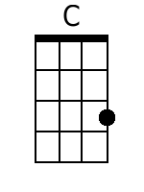
 |  |  |  |  |  |  |  | 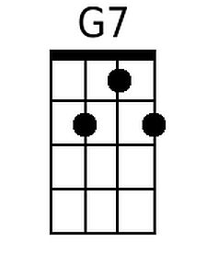
 |  |  |  |  |  |  |  | 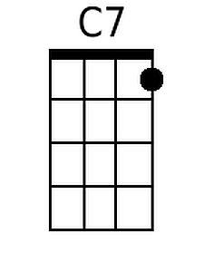
 |  |  |  |  |  |  |  | 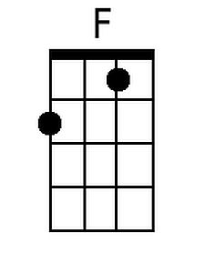
 |  |  |  |  |  |  |  | 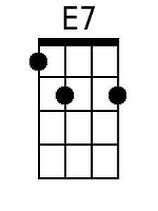
Baritone
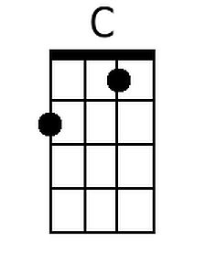 | 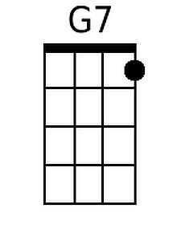 | 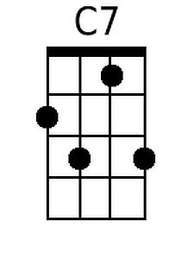 | 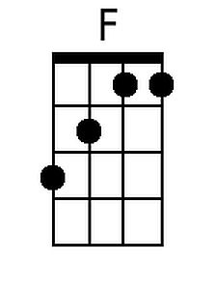 | 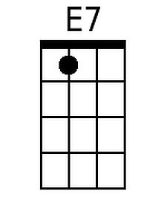

Note: “Syne” is not pronounced “Zyne” but should be pronounced with the soft s: “sign.”
Auld Lang Syne (G)
Updated Lyrics based on the Robert Burns poems by Doug Anderson
Tune: “Auld Lang Syne”

Intro (Last line of verse) C D7 G D7  G D7 C D7  Should our old friendships be for-got  G G7 C  And banished from the mind?  G D7 C D7  No, my old friends are like pure gold,  C D7 G - D7  Sin Auld Lang Syne.  Chorus  G D7  For those old times, my friend,  G G7 C  For auld lang syne.  G D7 C B7  We'll take a cup and warmly toast  C D7 G - D7  Those old days and times.  Outro:  G D7  For auld lang syne, my friend,  G G7 C  For auld lang syne,  G D7 C B7  We'll take a cup o' kindness, yet  C D7 G C D7 G  For auld lang syne. |  |  |  | G D7 C D7  At first, we shared the road as one,  G G7 C  But soon new paths we walked.  G D7 C D7  This meeting, friend, is sweet be-cause  C D7 G - D7  'Tis auld lang syne. Chorus  G D7 C D7  Those mem’ries sweet are oft re-called,  G G7 C  Those friendships, good and true.  G D7 C D7  It warms the heart, though we're a-part,  C D7 G - D7  For auld lang syne. Chorus  G D7 C D7  Now here's fresh glasses, fill them up,  G G7 C  Then pass them all a-round.  G D7 C D7  A toast to friendships that we've shared,  C D7 G - D7  For auld lang syne. Chorus |  |  |  | 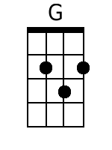
 |  |  |  |  |  |  |  | 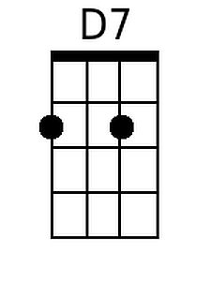
 |  |  |  |  |  |  |  | 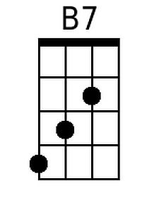
Baritone
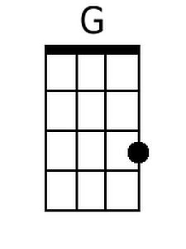 | 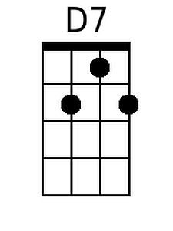 |  |  | 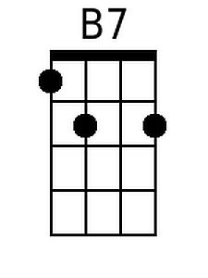

Note: “Syne” is not pronounced “Zyne” but should be pronounced with the soft s: “sign.”

