And I Love Her (Lennon-McCartney, 1964) (Am)

Intro (moderate strum): Dm | C | Dm | C |  Dm Am Dm Am  I give her all my love, that's all I do.  Dm Am F G7  And if you saw my love, you'd love her, too.  C  And I love her.  Dm Am Dm Am  She gives me everything, and tender-ly.  Dm Am F G7  The kiss my lover brings, she brings to me.  C  And I love her.  Bridge  Am G Am Em  ___ A love like ours ___ could never die  Am Em G7  ___ As long as I have you near me  Dm Am Dm Am  Bright are the stars that shine, dark is the sky.  Dm Am F G7  I know this love of mine could never die.  C  And I love her.  Instrumental Verse. Repeat Last Verse.  Outro:  Dm | C | Dm | C (Ring Out) |  |  |  |  |  |  |  |  | 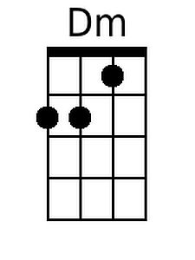
 |  |  |  |  |  |  |  |  | 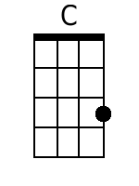
 |  |  |  |  |  |  |  |  | 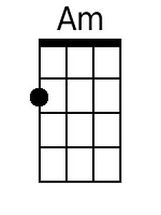
 |  |  |  |  |  |  |  |  | 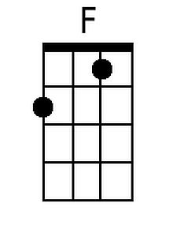
 |  |  |  |  |  |  |  |  | 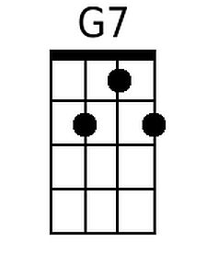
 |  |  |  |  |  |  |  |  | 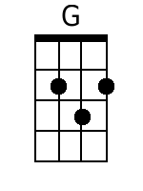
 |  | Bari | 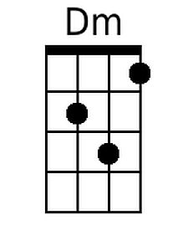 | 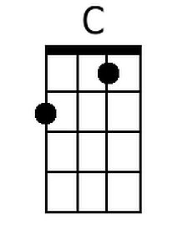 | 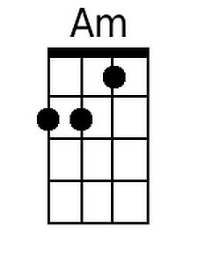 | 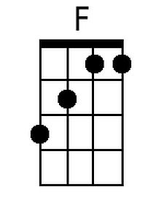 | 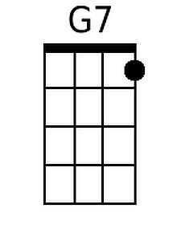 | 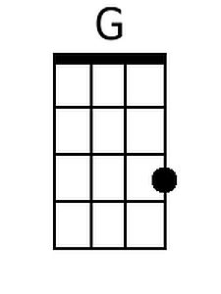

And I Love Her (Lennon-McCartney, 1964) (Dm)

Intro (moderate strum): Gm | F | Gm | F |  Gm Dm Gm Dm  I give her all my love, that's all I do.  Gm Dm Bb C7 F  And if you saw my love, you'd love her, too. And I love her.  Gm Dm Gm Dm  She gives me everything, and tender-ly.  Gm Dm Bb C7 F  The kiss my lover brings, she brings to me. And I love her.  Bridge  Dm C Dm Am  ___ A love like ours ___ could never die  Dm Am C7  ___ As long as I have you near me  Gm Dm Gm Dm  Bright are the stars that shine, dark is the sky.  Gm Dm Bb C7 F  I know this love of mine could never die. And I love her.  Instrumental Verse. Repeat Last Verse.  Outro:  Gm | F | Gm | F (Ring Out) |  |  |  |  |  |  |  |  | 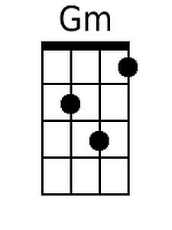
 |  |  |  |  |  |  |  |  | 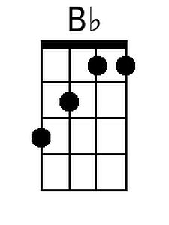
 |  |  |  |  |  |  |  |  | 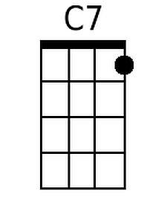
 |  | Bari | 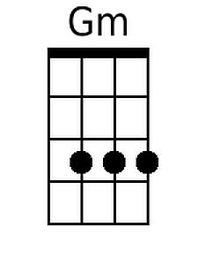 |  |  | 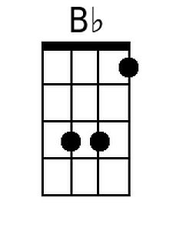 | 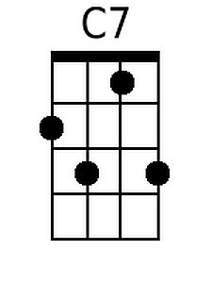

And I Love Her (Lennon-McCartney, 1964) (Em)

Intro ( moderate strum): Am | G | Am | G |

Am Em Am Em
I give her all my love, that's all I do.
Am Em C D7 G
And if you saw my love, you'd love her, too. And I love her.

Am Em Am Em
She gives me everything, and tender-ly.
Am Em C D7 G
The kiss my lover brings, she brings to me. And I love her.

Bridge
Em D Em Bm
___ A love like ours ___ could never die
Em Bm D7
___ As long as I have you near me

Am Em Am Em
Bright are the stars that shine, dark is the sky.
Am Em C D7 G
I know this love of mine could never die. And I love her.

Instrumental Verse. Repeat Last Verse.

Outro:
Am | G | Am | G (Ring Out)

 |  |  |  |  |  |  |  |  | 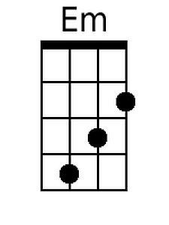
 |  |  |  |  |  |  |  |  | 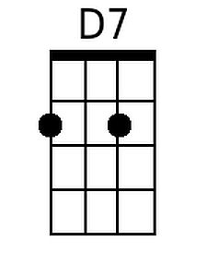
 |  |  |  |  |  |  |  |  | 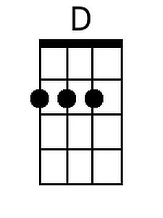
 |  | Bari |  |  | 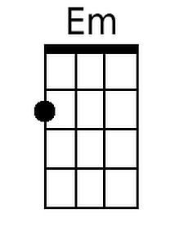 |  | 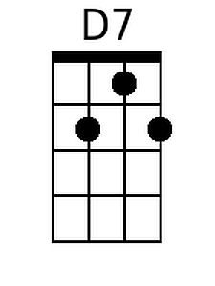 | 