Angels From The Realms of Glory
C104 C
Lyrics by James Montgomery (1816); Music "Regent Square" by Henry Smart (1867)
Angels from the Realms of Glory played and sung by Zack von Menchhofen, St. John's Lutheran Church, Richlandtown, PA. Text is from the Evangelical Lutheran Worship Book. #275.

Intro (Chords for Refrain) (Start note: G)

C  Angels, from the realms of glory,  F C Am G7 C  Wing your flight o'er all the earth;  C E7  Ye, who sang creation's sto-ry,  Am E7 Am G D7 G  Now pro-claim Mes-si-ah's birth.  Refrain  G G7 C7 F  Come and worship, Come and worship  Dm F Am G7 C  Worship Christ the newborn King.  C  Shepherds, in the fields abiding,  F C G7 C  Watching o'er your flocks by night,  C E7  God with man is now re-siding  Am E7 Am G D7 G  Yon-der shines the infant light. Refrain |  |  |  |  | C  Sages, leave your contemplations,  F C G7 C  Brighter visions beam a-far;  C E7  Seek the great Desire of nations,  Am E7 Am G D7 G  Ye have seen his natal star. Refrain  C  All creation, join in praising  F C G7 C  God, the Father, Spirit, Son,  C E7  Evermore your voices rai-sing  Am E7 Am G D7 G  To the e-ternal Three in One. Refrain
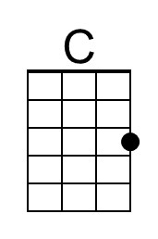 | 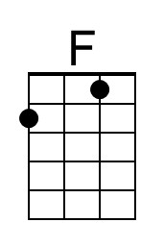 | 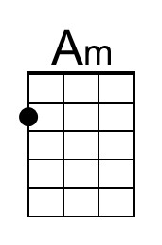 | 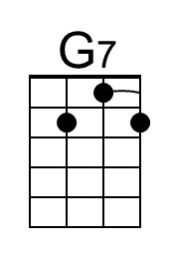 | 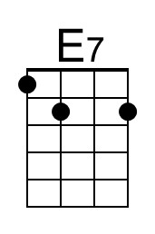 |  | 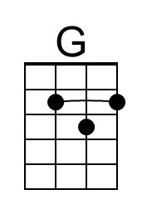 | 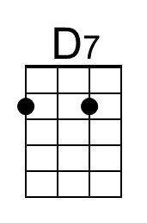 | 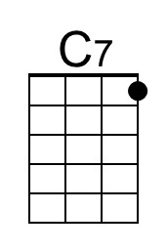 | 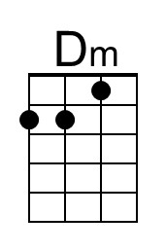
Baritone
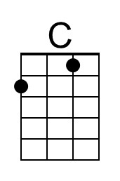 | 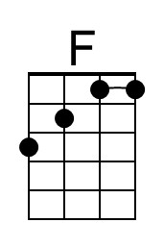 | 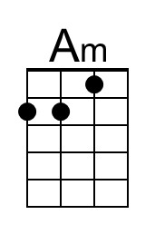 | 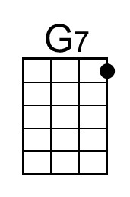 | 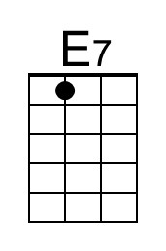 |  | 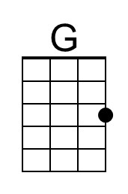 | 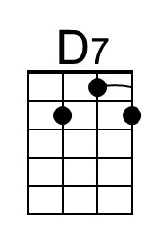 | 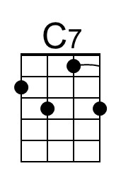 | 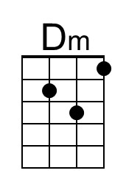

Angels From The Realms of Glory
C104 G
Lyrics by James Montgomery (1816); Music "Regent Square" by Henry Smart (1867)
Angels from the Realms of Glory played and sung by Zack von Menchhofen, St. John's Lutheran Church, Richlandtown, PA. Text is from the Evangelical Lutheran Worship Book. #275.

Intro (Chords for Refrain) (Start note: D)

G  Angels, from the realms of glory,  C G Em D7 G  Wing your flight o'er all the earth;  G B7  Ye, who sang creation's sto-ry,  Em B7 Em D A7 D  Now pro-claim Mes-si-ah's birth.  Refrain  D D7 G7 C  Come and worship, Come and worship  Am C Em D7 G  Worship Christ the newborn King.  G  Shepherds, in the fields abiding,  C G D7 G  Watching o'er your flocks by night,  G B7  God with man is now re-siding  Em B7 Em D A7 D  Yon-der shines the infant light. Refrain |  |  |  |  | G  Sages, leave your contemplations,  C G D7 G  Brighter visions beam a-far;  G B7  Seek the great Desire of nations,  Em B7 Em D A7 D  Ye have seen his natal star. Refrain  G  All creation, join in praising  C G D7 G  God, the Father, Spirit, Son,  G B7  Evermore your voices rai-sing  Em B7 Em D A7 D  To the e-ternal Three in One. Refrain
 |  | 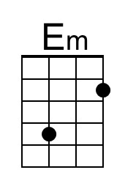 |  | 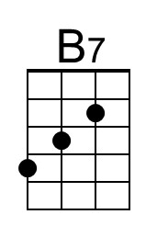 |  | 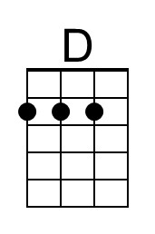 | 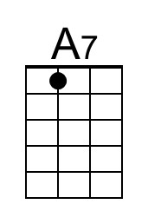
Baritone
 |  | 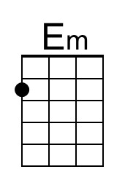 |  | 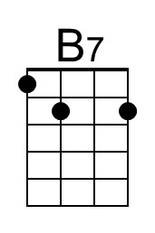 |  | 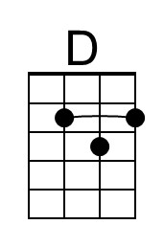 | 