Angels We Have Heard on High
C01 C
Les Anges dans nos campagnes, English lyrics by James Chadwick (1862)

Intro (Chords for the first line)

C G C G C
Angels we have heard on high, Sweetly singing o'er the plains,
G C G C
And the mountains in reply, Echoing their joyous strains.

Chorus
C A7 Dm G C F G
Glo...o….o….o….o..o..oria
C G C F C G
In ex cel sis De - o.
C A7 Dm G C F G
Glo...o….o….o….o.. o..oria
C G C F C G C
In excelsis D - e - o.

C G C G C
Shepherds, why this jubilee? Why your joyous strains prolong?
G C G C
What the gladsome tidings be which inspire your heavenly song? Chorus

C G C G C
Come to Bethlehem and see Him whose birth the angels sing;
G C G C
Come, adore on bended knee Christ, the Lord, the new-born King. Chorus

C G C G C
See him in a manger laid Jesus, Lord of heaven and earth;
G C G C
Mary, Joseph, lend your aid, with us sing our Savior's birth. Chorus

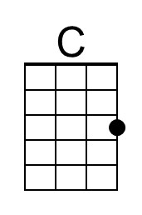 | 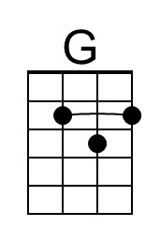 | 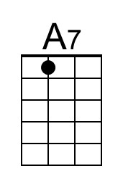 | 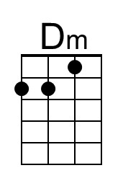 | 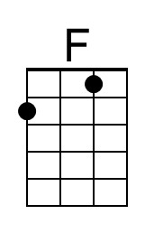
Baritone | 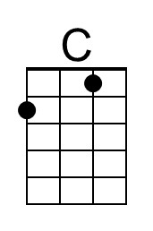 | 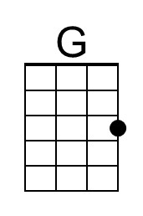 | 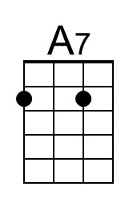 | 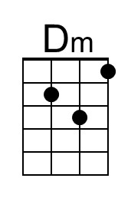 | 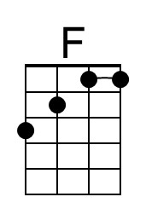

Angels We Have Heard on High
C01 G
Les Anges dans nos campagnes, English lyrics by James Chadwick (1862)

Intro (Chords for the first line)

G D G D G
Angels we have heard on high, Sweetly singing o'er the plains,
D G D G
And the mountains in reply, Echoing their joyous strains.

Chorus
G E7 Am D G C D
Glo...o….o….o….o..o..oria
G D G C G D
In ex cel sis De - o.
G E7 Am D G C D
Glo...o….o….o….o.. o..oria
G D G C G D G
In excelsis D - e - o.

G D G D G
Shepherds, why this jubilee? Why your joyous strains prolong?
D G D G
What the gladsome tidings be which inspire your heavenly song? Chorus

G D G D G
Come to Bethlehem and see Him whose birth the angels sing;
D G D G
Come, adore on bended knee Christ, the Lord, the new-born King. Chorus

G D G D G
See him in a manger laid Jesus, Lord of heaven and earth;
D G D G
Mary, Joseph, lend your aid, with us sing our Savior's birth. Chorus

 | 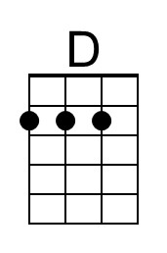 | 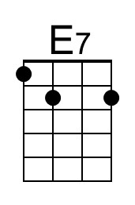 | 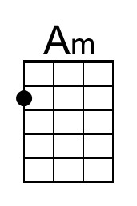
Baritone |  | 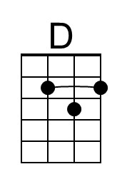 | 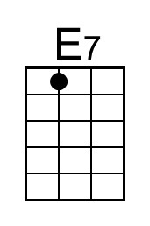 | 