**Angels We Have Heard on High**

C01-C

**C G C**

Angels we have heard on high,

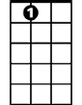

A7



G



C

**G C**

Sweetly singing o'er the plains,

**G C**

And the mountains in reply

**G C**

Echoing their joyous strains.

**Chorus:**

F

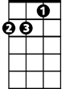

Dm

**C A7 Dm G C F G**

Glo...o….o….o….o..o..oria

**C G C F C G**

In ex cel sis De - o.

**C A7 Dm G C F G**

Glo...o….o….o….o.. o..oria

**C G C F C G C**

In excelsis D - e - o.

**C G C**

Shepherds, why this jubilee?

**G C**

Why your joyous strains prolong?

**G C**

What the gladsome tidings be

**BARITONE**

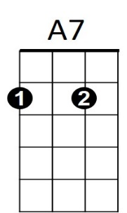 **G C**

C



G

Which inspire your heavenly song?

**(Chorus)**

**C G C**

Come to Bethlehem and see

**G C**

Him whose birth the angels sing;



F

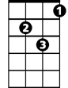

Dm

**G C**

Come, adore on bended knee

**G C**

Christ, the Lord, the new-born King.

**(Chorus)**

**C G C**

See him in a manger laid

**G C**

Jesus Lord of heaven and earth;

**G C**

Mary, Joseph, lend your aid,

**G C**

With us sing our Savior's birth.

**(Chorus)**

**Angels We Have Heard on High**

C01-G

**G D G**

Angels we have heard on high,

**D G**



C

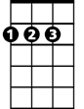

D



G

Sweetly singing o'er the plains,

**D G**

And the mountains in reply

**D G**

Echoing their joyous strains.

**Chorus:**

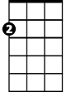

Am

E7

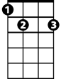

**G E7 Am D G C D**

Glo...o….o….o….o..o..oria

**G D G C G D**

In ex cel sis De - o.

**G E7 Am D G C D**

Glo...o….o….o….o.. o..oria

**G D G C G D G**

In excelsis D - e - o.

**G D G**

Shepherds, why this jubilee?

**D G**

Why your joyous strains prolong?

**D G**

What the gladsome tidings be

**BARITONE**

**D G**



G

C



D

Which inspire your heavenly song?

**(Chorus)**

**G D G**

Come to Bethlehem and see

**D G**



Am



E7

Him whose birth the angels sing;

**D G**

Come, adore on bended knee

**D G**

Christ, the Lord, the new-born King.

**(Chorus)**

**G D G**

See him in a manger laid

**D G**

Jesus Lord of heaven and earth;

**D G**

Mary, Joseph, lend your aid,

**D G**

With us sing our Savior's birth.

**(Chorus)**