Annie's Song (John Denver, 1974)
Key of C – ¾ Time (Waltz) – Annie’s Song by John Denver (Capo on 2)

Introduction (chords of last line)  C F G Am F C Em Am  You fill up my sen-ses, Like a night in the forest  C F G Dm F G G7  Like a mountain in spring-time, Like a walk in the rain  G F G Am F C Em Am  Like a storm in the des ert Like a sleepy blue ocean  C F G Dm G7 C C F C  You fill up my sen-ses, Come fill me a-gain  G7 C F C F C F C  Outro: Come fill me a-gain.  C F G Am F C Em Am  Come let me love you, Let me give my life to you  C F G Dm / F G G7  Let me drown in your laugh-ter, / Let me die in your arms  G F G Am F C Em Am  Let me lay down be-side you, Let me always be with you  C F G Dm / G7 C C F C  Come let me love you, / Come love me a-gain.  Instrumental (2 ½ lines)  C F G Am F C Em Am  You fill up my sen-ses, Like a night in the forest  C F G Dm F G G7  Like a mountain in spring-time, Like a walk in the rain  G F G Am F C Em Am  Like a storm in the des ert Let me give my life to you  C F G Dm / G7 C C F C  Come let me love you, / Come love me a-gain.  Repeat first verse to last phrase, then Outro. |  |  |  |  |  | 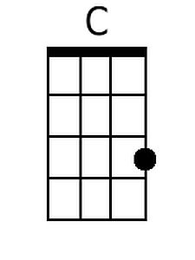
 |  |  |  |  |  | 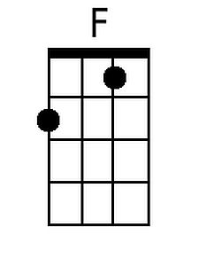
 |  |  |  |  |  | 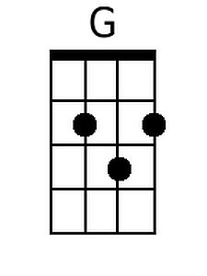
 |  |  |  |  |  | 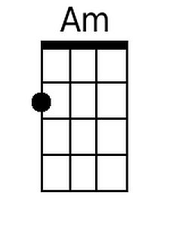
 |  |  |  |  |  | 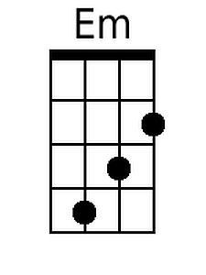
 |  |  |  |  |  | 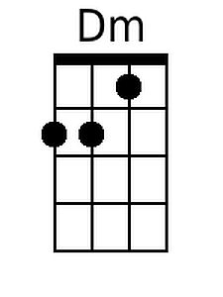
 |  |  |  |  |  | 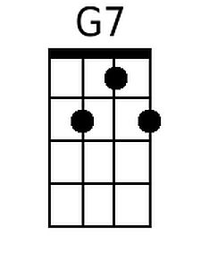
Bari:
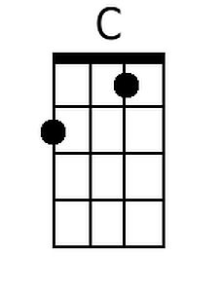 | 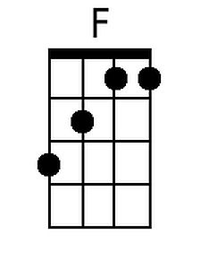 | 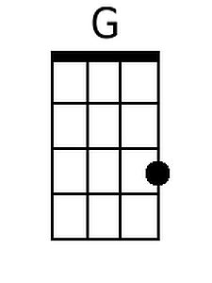 | 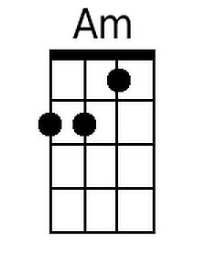 | 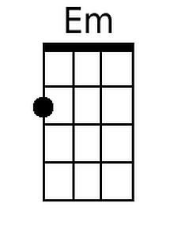 | 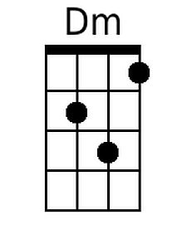 | 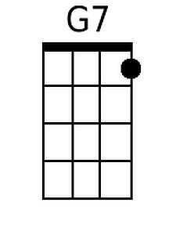

Annie's Song (John Denver, 1974)
Key of G – ¾ Time (Waltz) – Annie’s Song by John Denver

Introduction (chords of last line)

G C D Em C G Bm Em
You fill up my sen-ses , Like a night in the forest
G C D Am C D D7
Like a mountain in spring-time, Like a walk in the rain
D C D Em C G Bm Em
Like a storm in the des-ert, Like a sleepy blue ocean
G C D Am D7 G G C G
You fill up my sen- ses, Come fill me a-gain.
D7 G C G C G C G
Outro: Come fill me a-gain.

G C D Em C G Bm Em
Come let me love you, Let me give my life to you.
G C D Am C D D7
Let me drown in your laugh-ter, Let me die in your arms.
D C D Em C G Bm Em
Let me lay down be-side you, Let me al-ways be with you.
G C D Am D7 G G C G
Come let me love you, Come love me a-gain.

Instrumental (2 ½ lines)
G C D Em C G Bm Em
You fill up my sen-ses , Like a night in the forest
G C D Am C D D7
Like a mountain in spring-time, Like a walk in the rain
D C D Em C G Bm Em
Like a storm in the des-ert, Let me give my life to you.
G C D Am D7 G G C G
Come let me love you, Come love me a-gain.

Repeat first verse to last phrase, then Outro.
 |  |  |  |  |  | 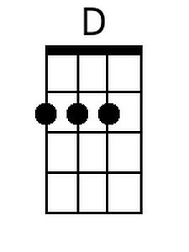
 |  |  |  |  |  | 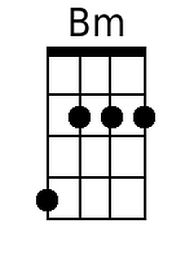
 |  |  |  |  |  | 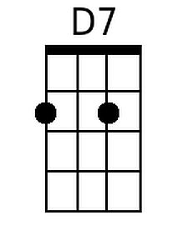
Bari:
 |  | 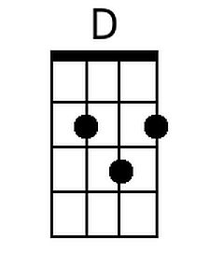 |  | 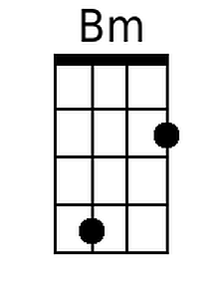 |  | 