Annie's Song
John Denver (1943-1997)

"Annie's Song" (also known as "Annie's Song (You Fill Up My Senses)") is a folk rock and country song recorded and written by singer-songwriter John Denver. The song was released as a single from Denver's album "Back Home Again." It was his second number-one song in the United States, occupying that spot for two weeks in July 1974. "Annie's Song" also went to number one on the Easy Listening chart. Billboard ranked it as the No. 25 song for 1974.
It went to number one in the United Kingdom, where it was Denver's only major hit single (many of Denver's American hits were more familiar in the UK through cover versions by other artists). Four years later, an instrumental version also became flutist James Galway's only major British hit.
"Annie's Song" was written as an ode to Denver's wife at the time, Annie Martell Denver. Denver "wrote this song in July 1973 in about ten-and-a-half minutes one day on a ski lift" to the top of Ajax Mountain in Aspen, Colorado, as the physical exhilaration of having "just skied down a very difficult run" and the feeling of total immersion in the beauty of the colors and sounds that filled all senses inspired him to think about his wife. Annie Denver recalls the beginnings: "It was written after John and I had gone through a pretty intense time together and things were pretty good for us. He left to go skiing and he got on the Ajax chair on Aspen mountain and the song just came to him. He skied down and came home and wrote it down... Initially it was a love song and it was given to me through him, and yet for him it became a bit like a prayer."
"The first time I heard 'Annie's Song,' I told John it had the same melody as Tchaikovsky's Fifth Symphony, Second Movement," says Milt Okun. "He walked over to the piano, sat for an hour and came back, and the only thing remaining from Tchaikovsky was the first five notes. It was fantastic."
Denver and Martell divorced in 1982. Denver was killed on October 12, 1997, when his experimental Rutan Long-EZ plane crashed into Monterey Bay near Pacific Grove, California, while making a series of touch-and-go landings at the nearby Monterey Peninsula Airport.

Source: Wikipedia, https://en.wikipedia.org/wiki/Annie's_Song

Annie's Song
John Denver (1973)
Key of C

Uke  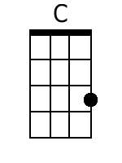  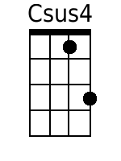  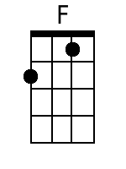  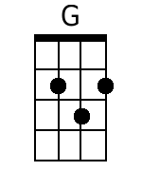  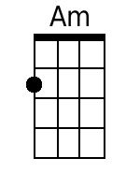  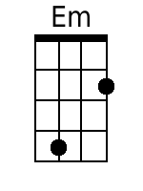  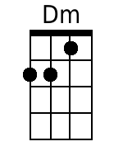  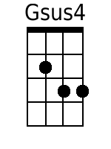  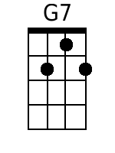 | [intro] C Csus4 C Csus4 C Csus4 C  Csus4 F G Am  1. You fill up my senses  F C Em Am  Like a night in the forest  G F Em Dm  Like the mountains in springtime  F G Gsus4 G  Like a walk in the rain  Gsus4 F G Am  Like a storm in the desert  F C Em Am  Like a sleepy blue ocean  G F Em Dm  You fill up my senses  G7 C Csus4 C  Come fill me again  Csus4 F G Am  2. Come let me love you  F C Em Am  Let me give my life to you  G F Em Dm  Let me drown in your laughter  F G Gsus4 G  Let me die in your arms  Gsus4 F G Am  Let me lay down beside you  F C Em Am  Let me always be with you  G F Em Dm  Come let me love you  G7 C Csus4 C  Come love me again  Repeat 1st Verse.  [outro] C Csus4 C Csus4 C Csus4 C | Baritone  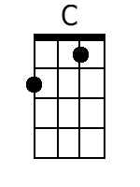  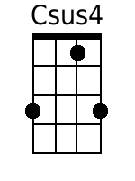  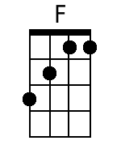  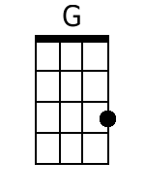  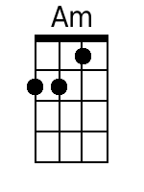  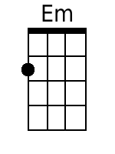  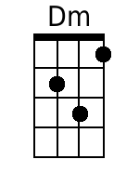  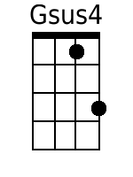  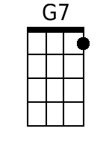

Annie's Song
John Denver (1973)
Key of D

Uke  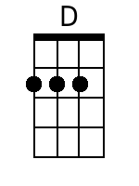  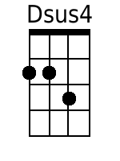  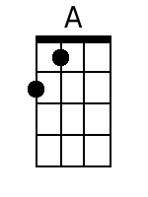  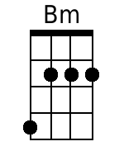  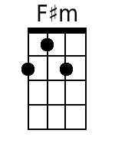  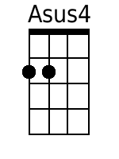  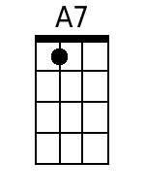 | [intro] D Dsus4 D Dsus4 D Dsus4 D  Dsus4 G A Bm  1. You fill up my senses  G D F#m Bm  Like a night in the forest  A G F#m Em  Like the mountains in springtime  G A Asus4 A  Like a walk in the rain  Asus4 G A Bm  Like a storm in the desert  G D F#m Bm  Like a sleepy blue ocean  A G F#m Em  You fill up my senses  A7 D Dsus4 D  Come fill me again  Dsus4 G A Bm  2. Come let me love you  G D F#m Bm  Let me give my life to you  A G F#m Em  Let me drown in your laughter  G A Asus4 A  Let me die in your arms  Asus4 G A Bm  Let me lay down beside you  G D F#m Bm  Let me always be with you  A G F#m Em  Come let me love you  A7 D Dsus4 D  Come love me again  Repeat 1st Verse.  [outro] D Dsus4 D Dsus4 D Dsus4 D | Baritone  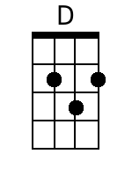  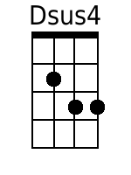  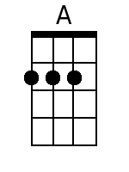  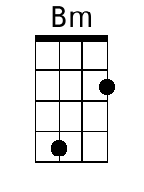  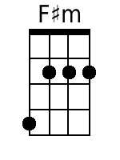  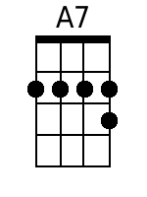

Annie's Song
John Denver (1973)
Key of G

Uke  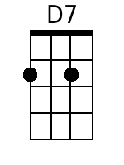 | [intro] G Gsus4 G Gsus4 G Gsus4 G  Gsus4 C D Em  1. You fill up my senses  C G Bm Em  Like a night in the forest  D C Bm Am  Like the mountains in springtime  C D Dsus4 D  Like a walk in the rain  Dsus4 C D Em  Like a storm in the desert  C G Bm Em  Like a sleepy blue ocean  D C Bm Am  You fill up my senses  D7 G Gsus4 G  Come fill me again  Gsus4 C D Em  2. Come let me love you  C G Bm Em  Let me give my life to you  D C Bm Am  Let me drown in your laughter  C D Dsus4 D  Let me die in your arms  Dsus4 C D Em  Let me lay down beside you  C G Bm Em  Let me always be with you  D C Bm Am  Come let me love you  D7 G Gsus4 G  Come love me again  Repeat 1st Verse.  [outro] G Gsus4 G Gsus4 G Gsus4 G | Baritone  