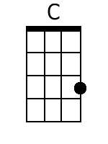
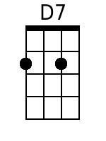
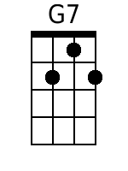
Anthem To Musubi
(a.k.a. “1, 2, 3 Spam Musubi”)
Ke'Ahi (Eric Rozet)
2016
https://www.youtube.com/watch?v=Y2UgSgJZ3Qk

Chorus:
C D7
1 2 3 spam musu-bi, 4 5 6 no need chopsticks
G7 C - G7
7 8 9 taste so divine, 10 let's do it again
C D7
1 2 3 spam musubi, 4 5 6 no need chopsticks
G7 C - G7
7 8 9 taste so divine, 10 let's do it again

C
1. Get the nori, smear it with rice,
D7
Then put inside, everything nice
G7 D7 G7
Wrap it up, and take a bite, It’ll blow your mind
C
Portuguese sausage, teriyaki chicken,
D7
Kim chee, dai kong, it’s so finger licken
G7 C - G7
Deep fry, no lie, that’s da secret weapon, Have a musubi.

Chorus

Instrumental: Chorus with an extra C - G7 at the end.

C
2. No matter where you are, land or sea,
D7
Don't forget your musubi
G7 D7 - G7
Keep it right, by your side, eat it day or night
C
Together, forever, in any kind of weather,
D7
I got my musubi and so the rest is just whatever
G7 C - G7
I want to tell the world, that we should all together, Have a musubi.

Spam Musubi is a popular snack and lunch food in Hawaii composed of a slice of grilled Spam on top of a block of rice, wrapped together with nori in the tradition of Japanese omusubi. Inexpensive and portable, Spam musubi are commonly found near cash registers in convenience stores all over Hawaii. "Nori" is an edible seaweed. Source: Spam Musabi (Wikipedia) | Baritone
 | 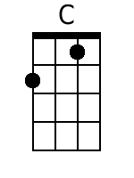 | 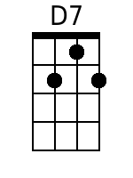 | 