Anticipation (Carly Simon) (C)

Intro C F C (2x)  C F C F C  We - can never know about the days to come  F Dm G  But - we think about them anyway - ay  C F C F C  And I wonder - if I'm real-ly with you now  F Dm G C F C  Or just chasing after some fi-i-ner day.  Chorus:  F C G F C  Anticipation, Anticipa - a - tion  F G F G  Is making me late ~ Is keeping me wa-a-i-iting.  C F C F C  And I tell you - how ea-sy it feels to be with you  F Dm G  And how right - your arms fe-el around me.  C F C F C  But I – I rehearsed those words just late last night  F Dm G C F C  When I was thinking about how right tonight might be. Chorus  C F C F C  And tomorrow - we might not be together  F Dm G  I'm no prophet - and I don't know Nature’s way  C F C F C  So I'll try - to see in-to your eyes right now  F Dm G C  And stay right here, 'cause these are the good old days.  F C  These are the good old days  F Dm G C  And stay right here, 'cause these are the good old days.  F C (3x)  These are the good old days  F F7 TACET C F C  These a - re - the good old days. | 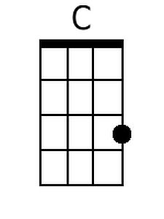 | 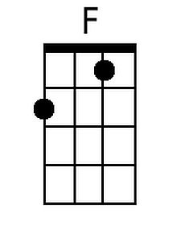
 | 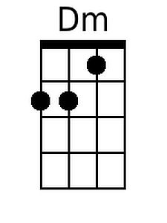 | 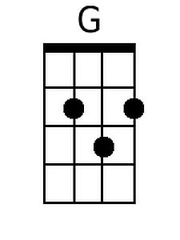
 | 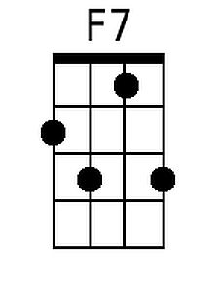
 | Bari
 | 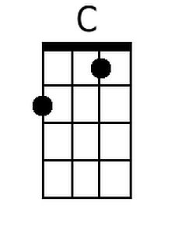 | 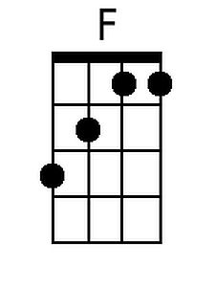
 | 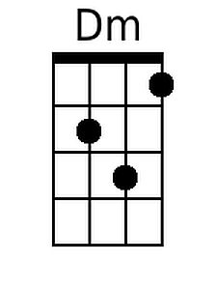 | 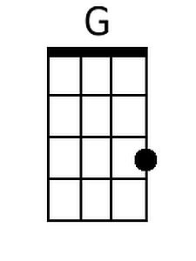
 | 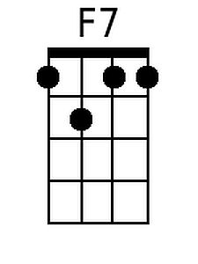

Features a distinctive strumming pattern.
Anticipation (Carly Simon) (G)

Intro G C G (2x)

G C G C G
We - can never know about the days to come
C Am D
But - we think about them anyway - ay
G C G C G
And I wonder - if I'm real-ly with you now
C Am D G C G
Or just chasing after some fi-i-ner day.

Chorus:
C G D C G
Anticipation, Anticipa - a - tion
C D C D
Is making me late ~ Is keeping me wa-a-i-iting

G C G C G
And I tell you - how ea-sy it feels to be with you
C Am D
And how right - your arms fe-el around me.
G C G C G
But I - I rehearsed those words just late last night
C Am D G C G
When I was thinking about how right tonight might be. Chorus

G C G C G
And tomorrow - we might not be together
C Am D
I'm no prophet - and I don't know Nature's way
G C G C G
So I'll try - to see in-to your eyes right now
C Am D G
And stay right here, 'cause these are the good old days.
C G
These are the good old days
C Am D G
And stay right here, 'cause these are the good old days.
C G (3x)
These are the good old days
C C7 TACET G C G
These a - re - the good old days
 | 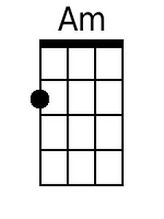 | 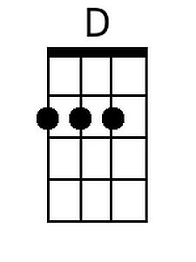
 | 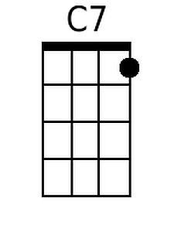
 | Bari
 | 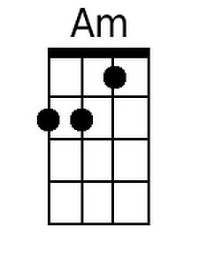 | 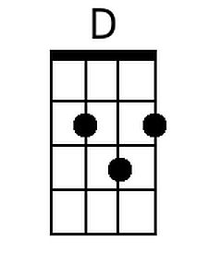
 | 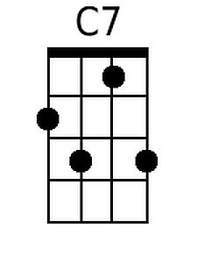

Features a distinctive strumming pattern.

