**Anticipation (Carly Simon)**

**Intro C F C (2x)**

**C F C F C**

We - can never know about the days to come

**F Dm G**



G



C

F



But - we think about them anyway - ay

**C F C F C**

And I wonder - if I'm real-ly with you now

**F Dm G C F C**

Or just chasing after some fi-i-ner day.

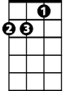

Dm

**Chorus:**

**F C G F C**

Anticipation, Anticipa - a - tion

**F G**

Is making me late ~

**F G**

Is keeping me wa-a-i-iting

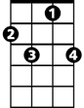

F7

**C F C F C**

And I tell you - how ea-sy it feels to be with you

**F Dm G**

And how right - your arms fe-el around me.

**C F C F C**

But I – I rehearsed those words just late last night

**F Dm G C F C**

When I was thinking about how right tonight might be.

**(CHORUS)**

**C F C F C**

**BARITONE**

And tomorrow - we might not be together

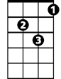

Dm



F

C



**F Dm G**

I'm no prophet - and I don't know Nature’s way

**C F C F C**

So I'll try - to see in-to your eyes right now

**F Dm G C**

And stay right here, 'cause these are the good old days.

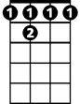

F 7

**F C**



G

These are the good old days

**F Dm G C**

And stay right here, 'cause these are the good old days.

**F C (3x)**

These are the good old days

**F F7 TACET C F C**

These a - re - the good old days