**Anything Goes (Cole Porter)**

**Intro: G / G6 / G / G7 / C / Cm / G / D7 /**

G6

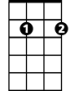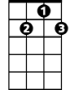

G7



G

**G G6**

In olden days a glimpse of stocking

**G G7**

Was looked on as something shocking

**C Cm G G6 Am7 D7**

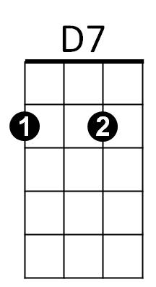Now heaven knows, anything goes

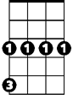

Cm



C



Am7

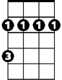

Bm

**G G6**

Good authors too who once knew better words

**G G7**

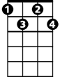

Fdim

now only use four letter words

**C Cm G F#7**

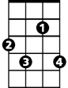

F#7

Writing prose, anything goes

**B7 F#7 B7**

The world has gone mad today and good's bad today

**F#7 B7**

And black's white today and day's night today

**Bm Bm7 Fdim D7**

When most guys today that women prize today are just silly gigo-los

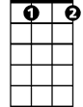

Gdim



Fdim

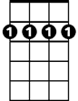

Bm7

**G G6**

So though I'm not a great romancer,

**G G7**

I know that you're bound to answer

**C Cm G G7**

When I pro-pose, anything goes

**C Cm G Gdim G6**

**BARITONE**

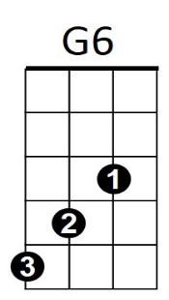Now it's time to close, 'cause anything goes!



D7

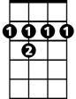

F#7

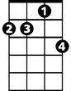

Am7

Bm

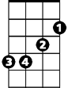

G

B7

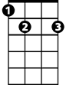

Bm7



Fdim

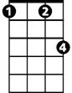

Cm

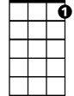

G7

C

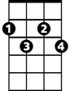

Gdim

**Anything Goes Original Lyrics (Cole Porter)**

Times have changed

And we've often rewound the clock

Since the Puritans got a shock

When they landed on Plymouth Rock.

If today any shock they should try to stem

'Stead of landing on Plymouth Rock,

Plymouth Rock would land on them.

In olden days a glimpse of stocking

Was looked on as something shocking

Now heaven knows, anything goes

If driving fast cars you like, if low bars you like,

If old hymns you like, if fair limbs you like,

If Mae West you like, or me undressed you like

Well no-body will op-pose

When every night the set that’s smart is intruding

in nudist parties in studios – anything goes

When Mrs. Ned McLean, God Bless her,

Can get Russian Reds to “yes” her, then I suppose-anything goes

When Rockefeller still can hoard e-

‘nuff money to let Max Gordon produce his shows, anything goes

The world has gone mad today and good's bad today

And black's white today and day's night today

And that gent today you gave a cent today once had several chateaux

When folks who still can ride in Jitneys

find out Vanderbilts and Whitneys lack baby clothes – anything goes

When Sam Goldwyn can with great conviction

Instruct Anna Sten in diction, then Nana shows – anything goes

When you hear that Lady Mendl standing up

now turns a handspring landing up on her toes– anything goes

Just think of those shocks you got, and those knocks you got

And those blues you got from those news you got

And those pains you got if any brains you got

From those little radi-os

So Mrs. R with all her trimmin’s

can broadcast a bed from Simmons

‘Cause Franklin knows – anything goes