**April Come She Will (Paul Simon) Key C**

**Intro: C F C F C**

**C F C F C F C**

A - pril, come she will

**Dm Am Bbmaj7 Am**

When streams are ripe and swelled with rain

**F G C Am**

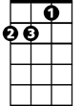

Dm

F



C



G

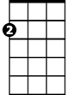

Am

Ma -y, she will sta - y

**Dm Am Dm Am C F C F**

Resting in my arms again

**C F C F C F C**

Ju - ne, she'll change her tune

**Dm Am Bbmaj7 Am**

In restless walks she'll prowl the night

**F G C Am**

Ju - ly, she will f - ly

**Dm Am Dm Am C F C F**

And give no warning to her flight

**C F C F C F C**

Au - gust, die she must

**Dm Am Bbmaj7 Am**

The autumn winds blow chilly and cold

**F G C Am**

Septe - mber, I'll remem-ber

**Dm Am G C C F C F C F C**

A love once new has now grown old

**BARITONE**

C

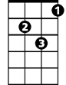

Dm



F



G



Am

**April Come She Will (Paul Simon) Key G**

**Intro: G C G C G**

**G C G C G C G**



Am



C



G

A - pril, come she will

**Am Em Fmaj7 Em**

When streams are ripe and swelled with rain

**C D G Em**

Ma -y, she will sta - y

Em

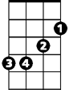

**Am Em Am Em G C G C**

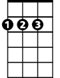

D

Resting in my arms again

**G C G C G C G**

Ju - ne, she'll change her tune

**Am Em Fmaj7 Em**

In restless walks she'll prowl the night

**C D G Em**

Ju - ly, she will f - ly

**Am Em Am Em G C G C**

And give no warning to her flight

**G C G C G C G**

Au - gust, die she must

**Am Em Fmaj7 Em**

The autumn winds blow chilly and cold

**C D G Em**

Septe - mber, I'll remem-ber

**Am Em D G G C G C G C G**

A love once new has now grown old

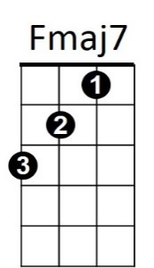



D



Em



Am



G

C



**BARITONE**