**April Love (Paul Francis Webster / Sammy Fain)**

**G Em7 Am7 D7 G Em7 Am7 D7**



G

Em7

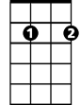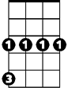

Cm

Ap...ril lo ve, is for the very young.

**G Em A7 D7 G D7**

Every star's a wishing star, that shines - for you.

**G Em7 Am7 D7 G Bm**

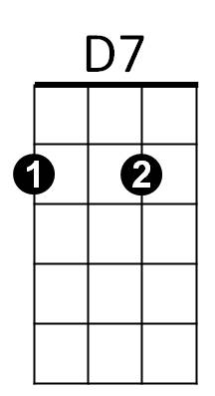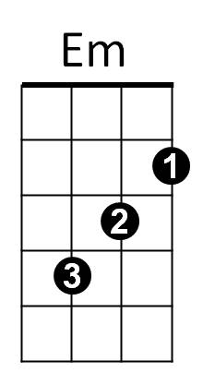Ap...ril love is all the seven wonders,



Am7

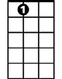

A7

**Em G D A7 Am7 D7**

One little kiss can tell you, this is true.

**Bm7 Am7 D7 Am7 D7 Am7 D7 G**

Some...times, an April day, will sudden..ly bring showers.

**Em7 A7 D A7 D7**

Rain to grow the flowers, for her first bou-quet.

**G Em7 Am7 D7 G Cm**

But Ap...ril love, can slip right through your fingers.

**G E7 Am7 D7 G D D7**

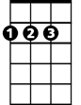

D

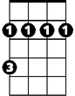

Bm

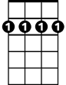

Bm7

So, if she's the one, don't let her run away.

**Bm7 Am7 D7 Am7 D7 Am7 D7 G**

Some...times, an April day, will sudden..ly bring showers.

**Em7 A7 D A7 D7**

Rain to grow the flowers, for her first bouquet.

**G Em7 Am7 D7 G Cm**

But Ap...ril love, can slip right through your fingers.

**G E7 Am7 D7 G D D7**

So, if she's the one, don't let her run a-way.

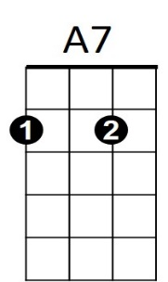

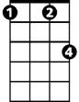

Cm

Bm

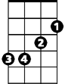

D

Bm7



G



Em7

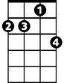

Am7

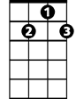

D7

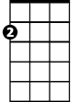

Em

**BARITONE**