**April Showers (Buddy DeSylva / Louis Silvers) Key C**

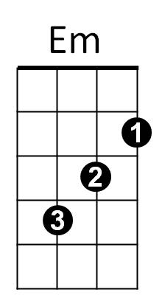**Prelude:**



G



C

**C G C G C G**

Life is not a Highway strewn with flowers

**C G C G C B7**

Still it holds a goodly share of bliss

**Em B7 Em B7 Em A7**

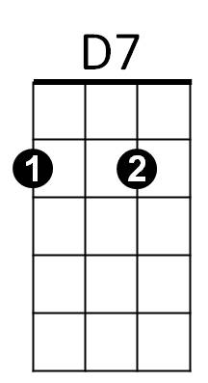When the sun gives way to April showers

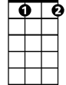

Gdim

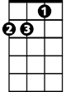

Dm

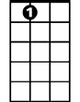

A7

**Dm D7 G Gdim G7**

Here’s the point - you should never miss

**G7 C**

Though April showers may come your way,

**G C**

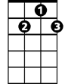

G7

F

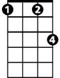

Fm

They bring the flowers that bloom in May.

**A7 Dm**

So if it's raining, have no regrets,

**D7 G7 Gdim G**

Because it isn't raining rain, you know, (It's raining vi -o - lets,)

**G7 C**

And where you see clouds upon the hills,

**A7 Dm**

You soon will see crowds of daffo-dils,

**F Fm C A7**

So keep on looking for a blue bird, And list'ning for his song,

**Dm G7 C**

**BARITONE**

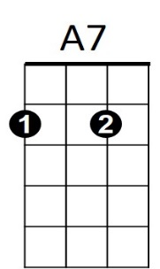Whenever April showers come along.

C



B7

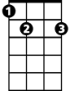

G

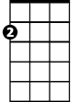

Em

**Gdim G7**

**(Instrumental First Verse)**

**(Sing Second Verse extend last line)**



D7



F

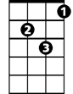

Dm

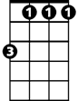

Fm

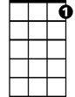

G7

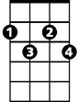

Gdim

**C G7 C**

E7



**April Showers (Buddy DeSylva / Louis Silvers) Key G**

**Prelude:**

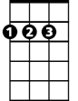

D

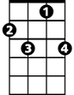

F7

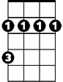

Bm



G

**G D G D G D**

Life is not a Highway strewn with flowers

**G D G D G F7**

Still it holds a goodly share of bliss

**Bm F7 Bm F7 Bm E7**

When the sun gives way to April showers

**Am A7 D Ddim D7**



Am

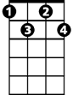

Ddim



A7

E7



Here’s the point - you should never miss

**D7 G**

Though April showers may come your way,

**D G**

****They bring the flowers that bloom in May.



C

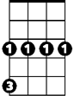

Cm

**E7 Am**

So if it's raining, have no regrets,

**A7 D7 Ddim D**

Because it isn't raining rain, you know, (It's raining vi -o - lets,)

**D7 G**

And where you see clouds upon the hills,

**E7 Am**

You soon will see crowds of daffo-dils,

**C Cm G E7**

So keep on looking for a blue bird, And list'ning for his song,

**Am D7 G**

Whenever April showers come along.

**BARITONE**



G

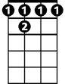

F 7



D

Bm

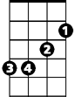

E7

**Ddim D7**

**(Instrumental First Verse)**

**(Sing Second Verse extend last line)**





D7

C



Cm



Ddim



Am

**G D7 G**

E7

