**As Tears Go By - Rolling Stones**

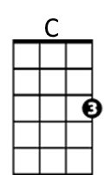**Intro: C D F G7**

F

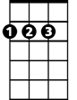

D

**C D F G7**

It is the evening of the da-ay

**C D F G7**

I sit and watch the children pla-ay

**F G7**

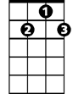

G7

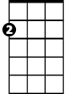

Am

Smiling faces I can see

**C Am**

But not for me

**F G7**

I sit and watch as tears go by

**C D F G7**

My richness can't buy everythi-ing

**C D F G7**

I want to hear the children si-ing

**F G7**

All I hear is the sound

**C Am**

**BARITONE**

of rain falling on the ground

C



D

**F G7**

I sit and watch as tears go by

**C D F G7**

It is the evening of the da-ay

**C D F G7**

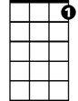

G7



F

I sit and watch the children pla-ay

**F G7**

Doing things I used to do

**C Am**

Thinking of you

**F G7**

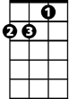

Am

I sit and watch as tears go by

**OUTRO (2x)**

**C D F G7**

Hmm Hmm Hmm Hmm Hmm Hmm Hmm Hmm