As Time Goes By
Herman Hupfeld (1931) - Key of C - From the movie "Casablanca"
As Time Goes By performed by "Sam" (Dooley Wilson) in Db Major

Intro: C2x Em2x F2x G72x  Dm G7 Gm G7  1. You must remember this, a kiss is just a kiss,  C Am – C – Em D D7 G  A sigh is just a sigh. The fundamental things ap-ply  G7 C – Em | F – G7 |  As time goes by.  Dm G7 Gm G7  2. And when two lovers woo, they still say “I love you”  C Am – C – Em D D7 G  On that you can re-ly. No matter what the future brings  G7 C – F – C – C7  As time goes by.  Bridge  F A7  Moonlight and love songs never out of date  Dm Ebdim7  Hearts full of passion, jealousy and hate  Am F7 D D7  Woman needs man and man must have his mate  G7 A7 Dm – G7  That no one can de-ny.  Dm G7 Gm G7  3. It’s still the same old story, a fight for love and glory  C Am – C – Em D D7 G  A case of do or die. The world will always welcome lovers  G7 C – F – C – C7  As time goes by.  Repeat From Bridge – Retard last line – Outro: C – F – G7 – C  Baritone |  |  |  |  |  | 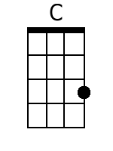 | 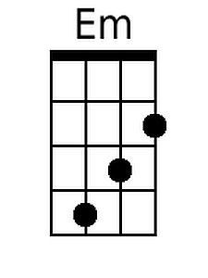
 |  |  |  |  |  | 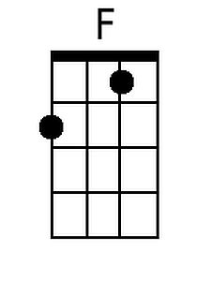 | 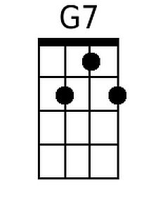
 |  |  |  |  |  | 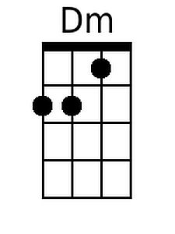 | 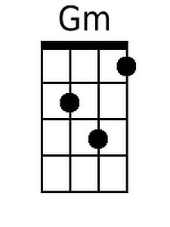
 |  |  |  |  |  | 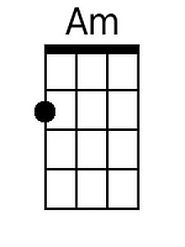 | 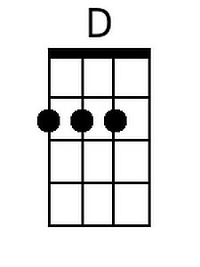
 |  |  |  |  |  | 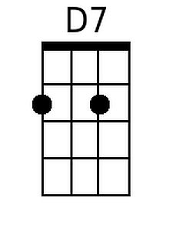 | 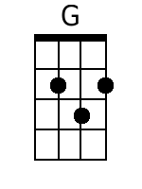
 |  |  |  |  |  | 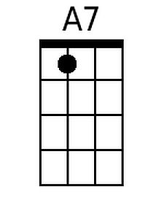 | 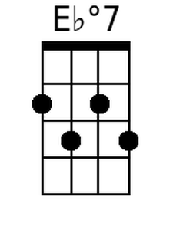
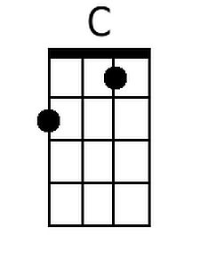 | 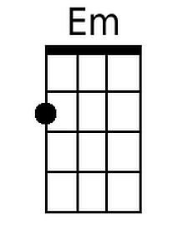 | 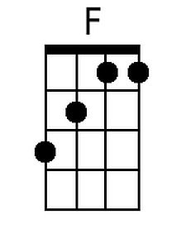 | 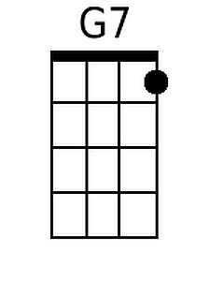 | 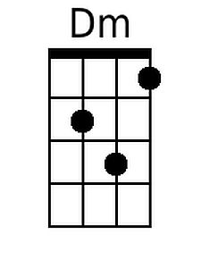 | 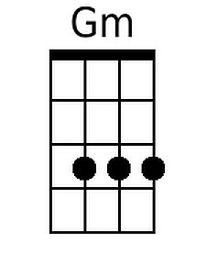 | 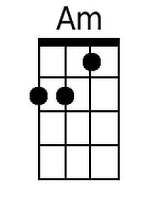 | 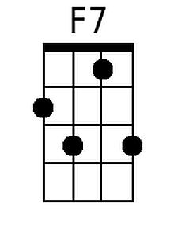
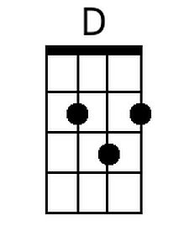 | 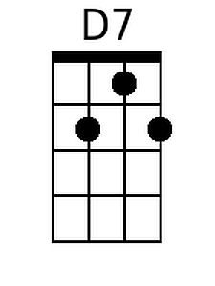 | 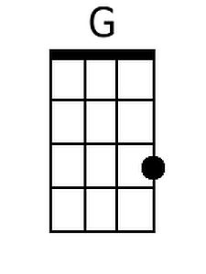 | 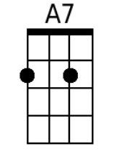 | 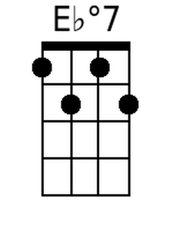
As Time Goes By
Herman Hupfeld (1931) - Key of G - From the movie "Casablanca"
As Time Goes By performed by "Sam" (Dooley Wilson) in Db Major

Intro: G^{2x} Bm^{2x} C^{2x} D7^{2x}  Am D7 Dm D7  1. You must remember this, a kiss is just a kiss,  G Em - G - Bm A A7 D  A sigh is just a sigh. The fundamental things ap-ply  D7 G - Bm | C - D7 |  As time goes by.  Am D7 Dm D7  2. And when two lovers woo, they still say "I love you"  G Em - G - Bm A A7 D  On that you can re-ly. No matter what the future brings  D7 G - C - G - G7  As time goes by.  Bridge  C E7  Moonlight and love songs never out of date  Am Bbdim7  Hearts full of passion, jealousy and hate  Em C7 A A7  Woman needs man and man must have his mate  D7 E7 Am - D7  That no one can de-ny.  Am D7 Dm D7  3. It's still the same old story, a fight for love and glory  G Em - G - Bm A A7 D  A case of do or die. The world will always welcome lovers  D7 G - C - G - G7  As time goes by.  Repeat From Bridge - Retard last line - Outro: G - C - D7 - G  Baritone |  |  |  |  |  |  | 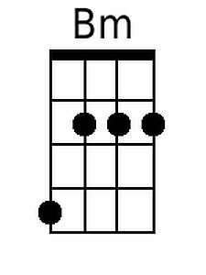
 |  |  |  |  |  |  | 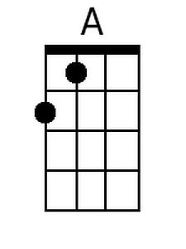
 |  |  |  |  |  | 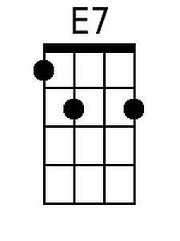 | 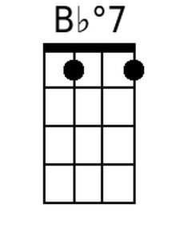
 | 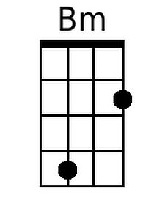 |  |  |  |  |  | 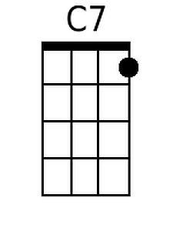
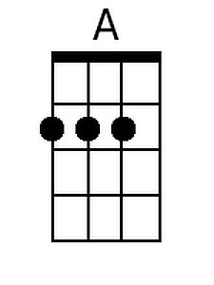 |  |  | 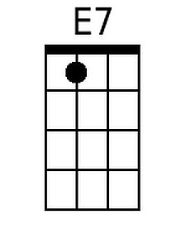 | 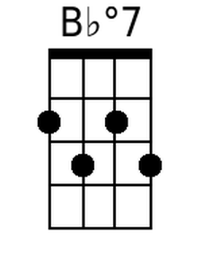 | 