As Time Goes By
Herman Hupfeld (1931) - Key of C - From the movie "Casablanca"
As performed by "Sam" (Dooley Wilson) in Db Major:
https://www.youtube.com/watch?v=d22CiKMPpaY

GCEA          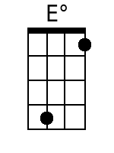  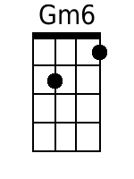  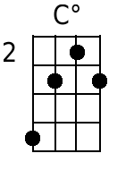    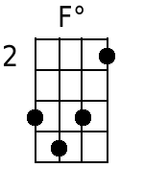  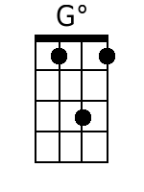 | Intro: D74x G74x Dm72x G72x C2x E°2x Dm72x G72x  (Last Two Lines of Verse)  D7 G7  1. You must remember this  Gm6 G7  A kiss is just a kiss  C Dm7 C° Em  A sigh is just a sigh  D7 G7  The fundamental things apply  Dm7 G7 C E° (F°?) Dm7 G7  As time goes by.  Dm7 G7  2. And when two lovers woo  Gm6 G7  They still say ‘ I love you’  C Dm7 C° Em  On that you can rely  D7 G7  No matter what the future brings  Dm7 G7 C F° C C7  As time goes by  Bridge  F A7  Moonlight and love songs never out of date  Dm C°  Hearts full of passion, jealousy and hate  Am Am+7? Am7 D7  Woman needs man and man must have his mate  G7 G° G7  That no one can deny  Dm7 G7  3. It’s still the same old story  Gm6 G7  A fight for love and glory  C Dm7 C° Em  A case of do or die  D7 G7  The world will always welcome lovers  Dm7 G C F° C  As time goes by  Repeat From Bridge | Bari          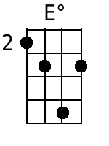  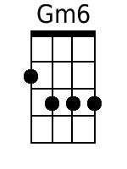  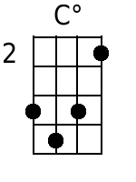    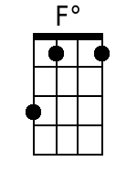  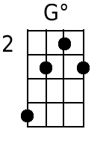

As Time Goes By
Herman Hupfeld (1931) - Key of C - From the movie "Casablanca"
As performed by "Sam" (Dooley Wilson) in Db Major:
https://www.youtube.com/watch?v=d22CiKMPpaY

GCEA     | Intro: A74x D74x Am72x D72x G2x B°2x Am72x D72x  (Last Two Lines of Verse)  A7 D7  1. You must remember this  Dm6 D7  A kiss is just a kiss  G Am7 G° Bm  A sigh is just a sigh  A7 D7  The fundamental things apply  Am7 D7 G B° Am7 D7  As time goes by.  Am7 D7  2. And when two lovers woo  Dm6 D7  They still say ‘ I love you’  G Am7 G° Bm  On that you can rely  A7 D7  No matter what the future brings  Am7 D7 G C° G G7  As time goes by  Bridge  C E7  Moonlight and love songs never out of date  Am G°  Hearts full of passion, jealousy and hate  Em Em+7 Em7 A7  Woman needs man and man must have his mate  D7 D° D7  That no one can deny  Am7 D7  3. It’s still the same old story  Dm6 D7  A fight for love and glory  G Am7 G° Bm  A case of do or die  A7 D7  The world will always welcome lovers  Am7 D G C° G  As time goes by  Repeat From Bridge | Bari    

