
Auld Lang Syne
C02 C
Based on the poem by Robert Burns, 1788
Version 1

Intro  F C C7 G7 F G7 C G7  (We'll take a cup of kindness yet for auld lang syne)  C C7 F G7  Should auld acquaintance be for-got  C C7 F  And never brought to mind?  C C7 F G7  Should auld acquaintance be for-got  F G7 C  And days of auld lang syne?  Chorus  G7 C G7  For auld lang syne, my dear,  C C7 F  For auld lang syne.  C C7 G7 E7  We’ll take a cup of kindness yet,  F G7 C  For auld lang syne.  C C7 F G7  We've wandered many weary miles  C C7 F  From morning sun till dine;  C C7 F G7  And seas be-tween us broad have roared  F G7 C  Since auld lang syne. Chorus  C C7 F G7  And here's a hand, my trusted friend!  C C7 F  And give a hand of yours!  C C7 F G7  And we'll take a deep draught of good-will  F G7 C  For auld lang syne. Chorus | 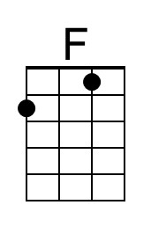 | 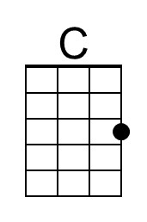
 | 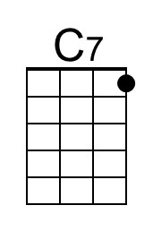 | 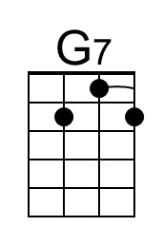
 | 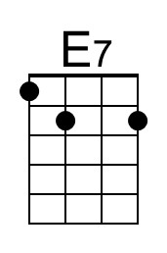
 | Baritone
 | 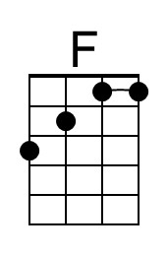 | 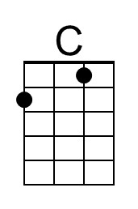
 | 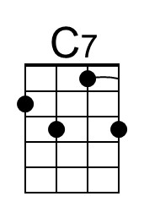 | 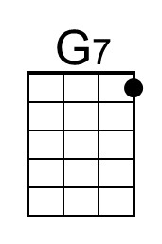
 | 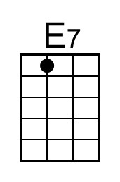
 | Pronounce “Syne” as “Sign”, not “Zyne”

Auld Lang Syne
C02 G
Based on the poem by Robert Burns, 1788
Version 1

Intro  C G G7 D7 B7 C D7 G D7  (We'll take a cup of kindness yet for auld lang syne)  G G7 C D7  Should auld acquaintance be for-got  G G7 C  And never brought to mind?  G G7 C D7  Should auld acquaintance be for-got  C D7 G  And days of auld lang syne?  Chorus  D7 G D7  For auld lang syne, my dear,  G G7 C  For auld lang syne.  G G7 D7 B7  We’ll take a cup of kindness yet,  C D7 G  For auld lang syne.  G G7 C D7  We've wandered many weary miles  G G7 C  From morning sun till dine;  G G7 C D7  And seas be-tween us broad have roared  C D7 G  Since auld lang syne. Chorus  G G7 C D7  And here's a hand, my trusted friend!  G G7 C  And give a hand of yours!  G G7 C D7  And we'll take a deep draught of good-will  C D7 G  For auld lang syne. Chorus |  | 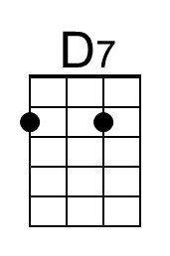
 | 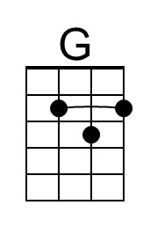
 | 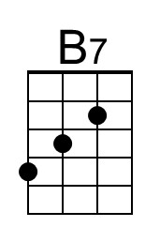
 | Baritone
 |  | 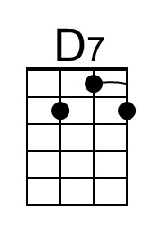
 | 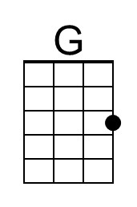
 | 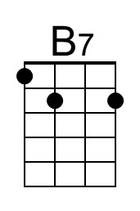
 | Pronounce “Syne” as “Sign”, not “Zyne”

