**Auld Lang Syne**

C02

**C C7 F G7**

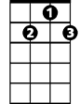

G7



C

Should auld acquaintance be for-got

**C C7 F**

And never brought to mind?

**C C7 F G7**

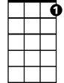

C7

F



Should auld acquaintance be for-got

**F G7 C**

And days of auld lang syne?

**G7 C G7**

E7

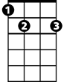

For auld lang syne, my dear,

**C C7 F**

For auld lang syne

**C C7 G7 E7**

We’ll take a cup of kindness yet,

**F G7 C**

For auld lang syne

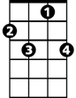

C7



G7

C



**BARITONE**



F

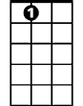

E7