Auld Lang Syne (C)
Written by Robert Burns 1788, traditional Scottish tune; Arrangement by Theresa Miller

Intro:  F C Am G7 E7 F G7 C  (We'll take a cup o' kindness yet for auld lang syne)  G7 C Am G7 C#º7 G7  Should auld acquaintance be for - got  C C7 F F#º7  And never brought to mind?  C Am G7 C#º7 G7  Should auld acquaintance be for - got  E7 F G7 C  And days of auld lang syne?  G7 C Am G7 C#º7 G7  For auld lang syne, my dear  C C7 F F#º7  For auld lang syne  C Am G7 C#º7 G7  We'll take a cup o' kind-ness yet  E7 F G7 C  For auld lang syne  C7 F G7 F C  For auld lang sy----yne. |  |  |  |  |  |  | 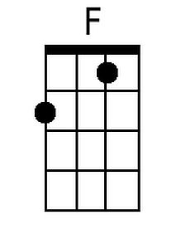 | 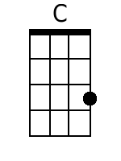
 |  |  |  |  |  |  | 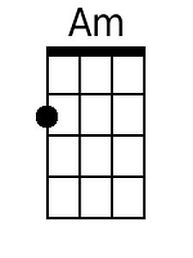 | 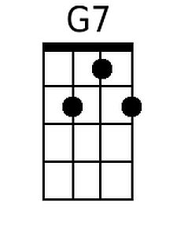
 |  |  |  |  |  |  | 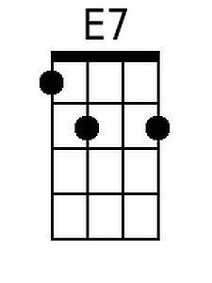 | 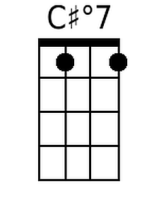
 |  |  |  |  |  |  | 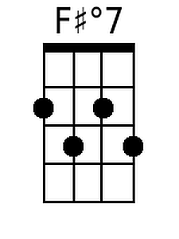
Bari
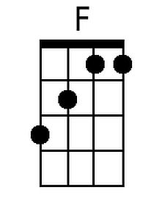 | 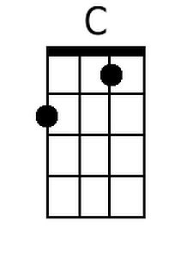 | 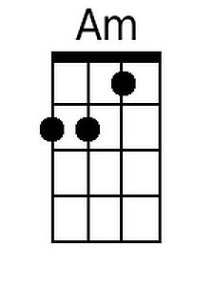 | 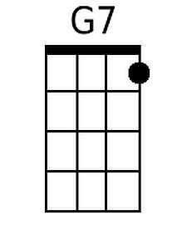 | 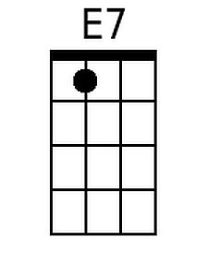 | 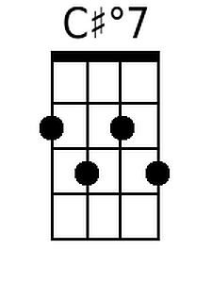 | 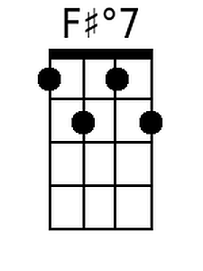

Auld Lang Syne (G)
Written by Robert Burns 1788, traditional Scottish tune; Arrangement by Theresa Miller

Intro:  C G Em D7 B7 C D7 G  (We'll take a cup o' kindness yet for auld lang syne)  D7 G Em D7 Abº7 D7  Should auld acquaintance be for - got  G G7 C C#º7  And never brought to mind?  G Em D7 Abº7 D7  Should auld acquaintance be for - got  B7 C D7 G  And days of auld lang syne?  D7 G Em D7 Abº7 D7  For auld lang syne, my dear  G G7 C C#º7  For auld lang syne  G Em D7 Abº7 D7  We'll take a cup o' kind-ness yet  B7 C D7 G  For auld lang syne  G7 C D7 C G  For auld lang sy----yne. |  |  |  |  |  |  |  | 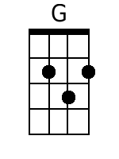
 |  |  |  |  |  |  | 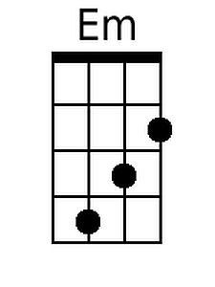 | 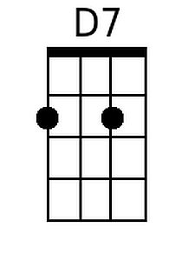
 |  |  |  |  |  |  | 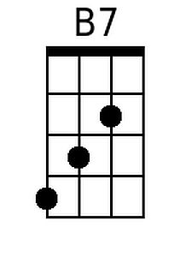 | 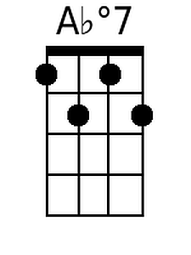
Bari
 | 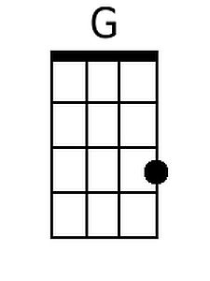 | 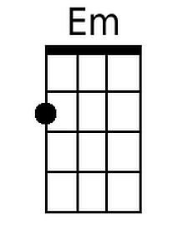 | 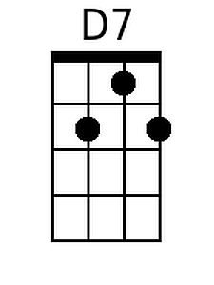 | 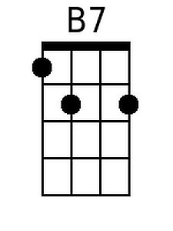 | 