Auld Lang Syne (James Taylor) (D)
James Taylor’s Auld Lang Syne (4 chord version)

A7 D A7  Should auld acquaintance be forgot  D D7 G  And never brought to mind?  D A7  Should auld acquaintance be forgot  G A7 D  And days of auld lang syne?  D A7  For auld lang syne,  D G  For auld lang syne  D A7  Should auld acquaintance be forgot  G A7 D  And days of auld lang syne  A7 D A7  We two have run a-bout the hills  D D7 G  And gathered up flowers fine  D A7  But we've wandered many a weary foot  G A7 D  Since auld lang syne  A7 D A7  We two have sported in the brook  D D7 G  From morning sun till dine  D  But the seas between us have  A7 G A7 D  Roared and swelled since auld lang syne. |  |  |  | G D A7  For auld lang syne,  D D7 G  For auld lang syne  D  The seas between us have  A7  Roared and swelled.  G A7 D  Since auld lang syne.  A7 D A7  So, here's a hand, my trusty friend  D D7 G  And give me a hand of thine  D A7  We'll take a cup of kindness yet  G A7 D  For auld lang syne  G D A7  For auld lang syne,  D D7 G  For auld lang syne  D A7  We'll take a cup of kindness yet  G A7 D  For auld lang syne  G A7 D  For auld lang syne. |  |  |  | 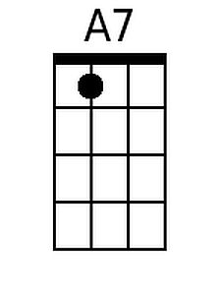
 |  |  |  |  |  |  |  | 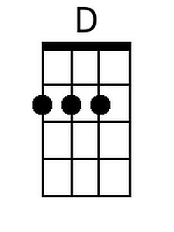
 |  |  |  |  |  |  |  | 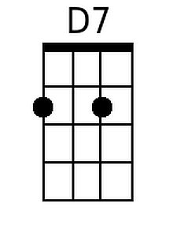
 |  |  |  |  |  |  |  | 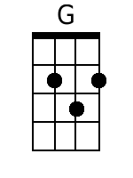
Baritone
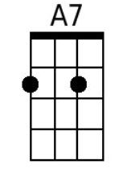 | 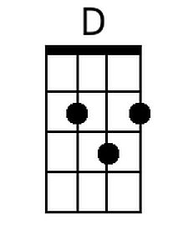 | 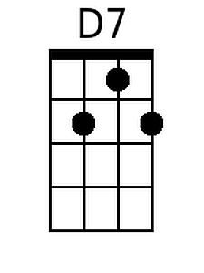 | 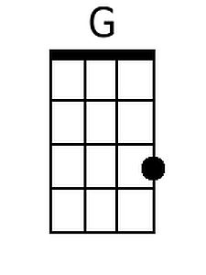

Auld Lang Syne (James Taylor) (G)
James Taylor’s Auld Lang Syne (4 chord version)

D7 G D7  Should auld acquaintance be forgot  G G7 C  And never brought to mind?  G D7  Should auld acquaintance be forgot  C D7 G  And days of auld lang syne?  G D7  For auld lang syne,  G C  For auld lang syne  G D7  Should auld acquaintance be forgot  C D7 G  And days of auld lang syne  D7 G D7  We two have run a-bout the hills  G G7 C  And gathered up flowers fine  G D7  But we've wandered many a weary foot  C D7 G  Since auld lang syne  D7 G D7  We two have sported in the brook  G G7 C  From morning sun till dine  G  But the seas between us have  D7 C D7 G  Roared and swelled since auld lang syne. |  |  |  | C G D7  For auld lang syne,  G G7 C  For auld lang syne  G  The seas between us have  D7  Roared and swelled.  C D7 G  Since auld lang syne.  D7 G D7  So, here's a hand, my trusty friend  G G7 C  And give me a hand of thine  G D7  We'll take a cup of kindness yet  C D7 G  For auld lang syne  C G D7  For auld lang syne,  G G7 C  For auld lang syne  G D7  We'll take a cup of kindness yet  C D7 G  For auld lang syne  C D7 G  For auld lang syne.
 |  |  |  |  |  |  |  | 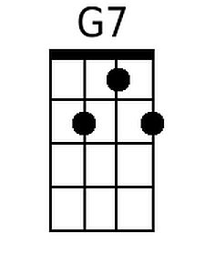
 |  |  |  |  |  |  |  | 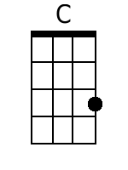
Baritone
 |  | 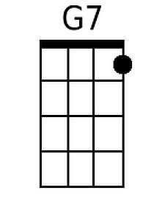 | 