Auld Lang Syne (James Taylor) (D)
James Taylor’s Auld Lang Syne

A7 D Bm7 A7  Should auld ac-quaintance be forgot,  D D7 G  And never brought to mind?  D Bm7 A7 Gdim7  Should auld ac-quaintance be for-got,  G A7 D  And days of auld lang syne?  G D A7  For auld lang syne,  G D D7 G Ddim7  For auld lang syne  D Bm7  Should auld ac-quaintance  A7 Gdim7  Be for-got  G A7 D  And days of auld lang syne  A7 D Bm7 A7  We two have run a-bout the hills  D D7 G  And gathered up flowers fine  D Bm7 A7 Gdim7  But we've wandered many a weary foot  G A7 D  Since auld lang syne.  A7 D Bm7 A7  We two have sported in the brook  D D7 G  From morning sun till dine  D Bm7  But the seas between us have  A7 Gdim7 G A7 D  Roared and swelled since auld lang syne |  |  |  | G D A7  For auld lang syne,  D D7 G Ddim7  For auld lang syne  D Bm7  The seas be-tween us have  A7 Gdim7  roared and swelled  G A7 D  Since auld lang syne.  A7 D Bm7 A7  So, here's a hand, my trusty friend  D D7 G Ddim7  And give me a hand of thine  D Bm7 A7 Gdim7  We'll take a cup of kindness yet  G A7 D  For auld lang syne  G D A7  For auld lang syne,  D D7 G Ddim7  For auld lang syne  D Bm7 A7 Gdim7  We'll take a cup of kindness yet  G A7 D  For auld lang syne  Bm7 G A7 D  For auld lang syne. |  |  |  | 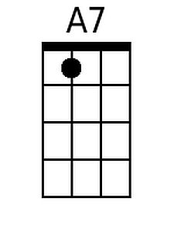
 |  |  |  |  |  |  |  | 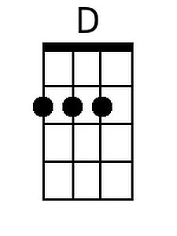
 |  |  |  |  |  |  |  | 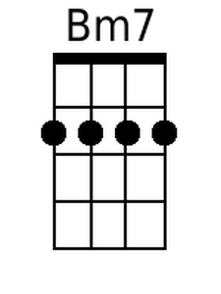
 |  |  |  |  |  |  |  | 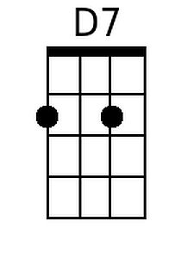
 |  |  |  |  |  |  |  | 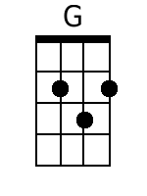
 |  |  |  |  |  |  |  | 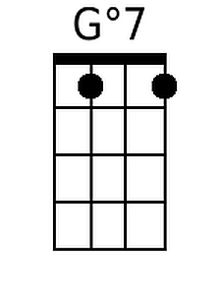
 |  |  |  |  |  |  |  | 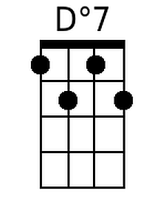
Baritone
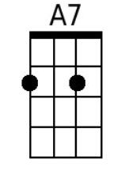 | 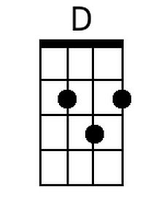 | 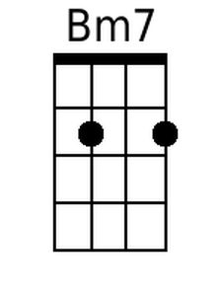 | 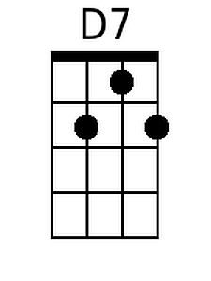 | 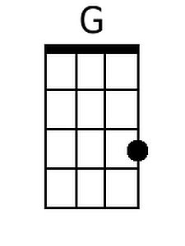 | 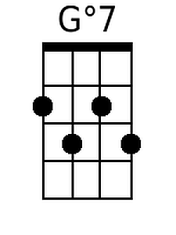 | 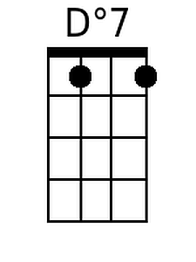

Auld Lang Syne (James Taylor) (G)
James Taylor’s Auld Lang Syne

D7 G Em7 D7  Should auld ac-quaintance be forgot,  G G7 C  And never brought to mind?  G Em7 D7 Cdim7  Should auld ac-quaintance be for-got,  C D7 G  And days of auld lang syne?  C G D7  For auld lang syne,  C G G7 C Gdim7  For auld lang syne  G Em7  Should auld ac-quaintance  D7 Cdim7  Be for-got  C D7 G  And days of auld lang syne  D7 G Em7 D7  We two have run a-bout the hills  G G7 C  And gathered up flowers fine  G Em7 D7 Cdim7  But we've wandered many a weary foot  C D7 G  Since auld lang syne  D7 G Em7 D7  We two have sported in the brook  G G7 C  From morning sun till dine  G Em7  But the seas between us have  D7 Cdim7 C D7 G  Roared and swelled since auld lang syne |  |  |  | C G D7  For auld lang syne,  G G7 C Gdim7  For auld lang syne  G Em7  The seas be-tween us have  D7 Cdim7  roared and swelled  C D7 G  Since auld lang syne.  D7 G Em7 D7  So, here's a hand, my trusty friend  G G7 C Gdim7  And give me a hand of thine  G Em7 D7 Cdim7  We'll take a cup of kindness yet  C D7 G  For auld lang syne  C G D7  For auld lang syne,  G G7 C Gdim7  For auld lang syne  G Em7 D7 Cdim7  We'll take a cup of kindness yet  C D7 G  For auld lang syne  Em7 C D7 G  For auld lang syne.
 |  |  |  |  |  |  |  | 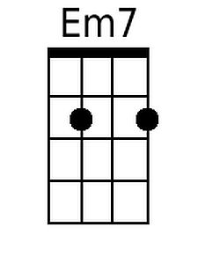
 |  |  |  |  |  |  |  | 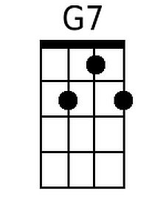
 |  |  |  |  |  |  |  | 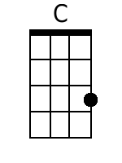
 |  |  |  |  |  |  |  | 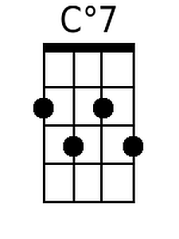
Baritone
 |  | 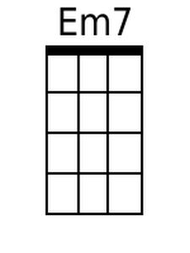 | 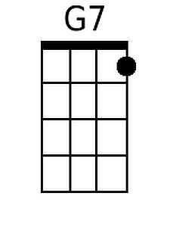 | 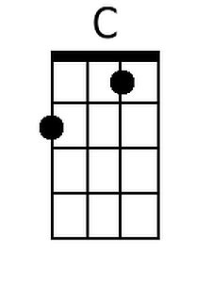 | 