Autumn Leaves

**French lyrics by Jacques Prévert, Music by Joseph Kosma, 1945**

**English Lyrics by Johnny Mercer, 1947**

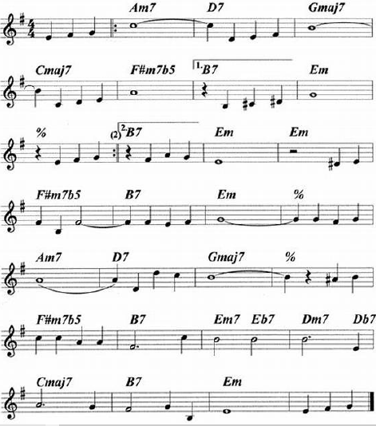

**Autumn Leaves**

**French lyrics by Jacques Prévert, Music by Joseph Kosma, 1945**

**English Lyrics by Johnny Mercer, 1947**

[**Autumn Leaves**](https://www.youtube.com/watch?v=i6e1-2yxQPs) **by Johnny Mercer (1947);** [**Autumn Leaves**](https://www.youtube.com/watch?v=TrG6AAPPujQ) **by Frank Sinatra (1957)**

**Chords for C-Tuned and G-Tuned Ukulele**

|  |  |  |  |  |  |  |  |
| --- | --- | --- | --- | --- | --- | --- | --- |
| **Em Am7 D7 Gmaj7**  The falling leaves __ drift by my window  **Cmaj7 F#m7♭5 B7 Em**  _____ The falling leaves __ of red and gold  **Em Am7 D7 Gmaj7**  I see your lips, __ the summer kisses  **Cmaj7 F#m7♭5 B7 Em**  _____ The sunburned hands, __ I used to hold    **Chorus**  **F#m7♭5 B7 Em**  Since you went away __ the days grow long  **Am7 D7 Gmaj7**  And soon I'll hear __ old winter's song  **F#m7♭5 B7 Em7 E♭7 Dm7**  But I miss you most of all, my darl - ing  **D♭7 Cmaj7 B7 Em**  When autumn leaves start to fall. | | | | | |  |  |
|  |  |
|  |  |
|  |  |
| **G-Tuned Uke**  **(Bari)** |  |  |  |  |  |  |  |
|  |  |  |  |  |  |  |  |

**Autumn Leaves**

**French lyrics by Jacques Prévert, Music by Joseph Kosma, 1945**

**English Lyrics by Johnny Mercer, 1947**

[**Autumn Leaves**](https://www.youtube.com/watch?v=i6e1-2yxQPs) **by Johnny Mercer (1947);** [**Autumn Leaves**](https://www.youtube.com/watch?v=TrG6AAPPujQ) **by Frank Sinatra (1957)**

**Em Am7 D7 Gmaj7**

The falling leaves __ drift by my window

**Cmaj7 F#m7b5 B7 Em**

_____ The falling leaves __ of red and gold

**Em Am7 D7 Gmaj7**

I see your lips, __ the summer kisses

**Cmaj7 F#m7b5 B7 Em**

_____ The sunburned hands, __ I used to hold

**Chorus**

**F#m7b5 B7 Em**

Since you went away __ the days grow long

**Am7 D7 Gmaj7**

And soon I'll hear __ old winter's song

**F#m7♭5 B7 Em7 E♭7 Dm7**

But I miss you most of all, my darl - ing

**D♭7 Cmaj7 B7 Em**

When autumn leaves start to fall.