Autumn Leaves (Am)
"Les feuilles mortes" (French lyrics) by Jacques Prévert, Music by Joseph Kosma, 1945
English Lyrics by Johnny Mercer, 1947; Autumn Leaves by Johnny Mercer (1947) (Cm)
Version 2 – 2/2 Time – 81 BPM

Intro Chords for Verse.  Am Dm7 G7 C  The falling leaves __ drift by my window,  Bm7♭5 E7 Am  The autumn leaves __ of red and gold.  Dm7 G7 C  I see your lips, __ the summer kisses  Bm7♭5 E7 Am  The sunburned hands, __ I used to hold  Chorus  E7 Am  Since you went away, the days grow long  G7 C  And soon I'll hear __ old winter's song  E7♭9 E7 Am  But I miss you most of all, my darling  D Dm E7 Am  When au-tumn leaves start to fall.  Instrumental Verse. Repeat Chorus. Outro: Dm – Am |  |  |  |  |  | 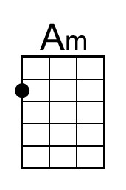 | 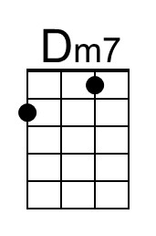
 |  |  |  |  |  | 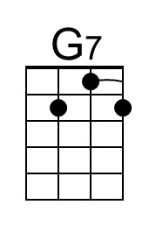 | 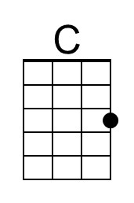
 |  |  |  |  |  | 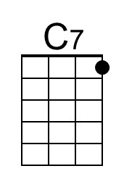 | 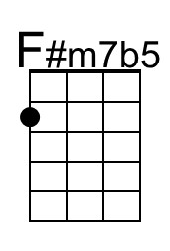
 |  |  |  |  |  | 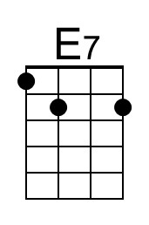 | 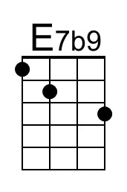
 |  |  |  |  |  | 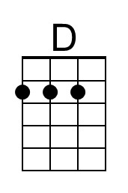 | 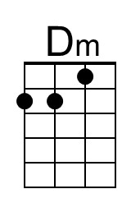
G-Tuned Uke  (Bari) | 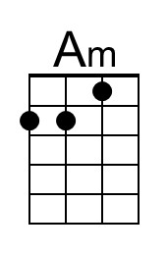 | 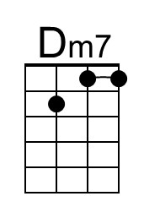 | 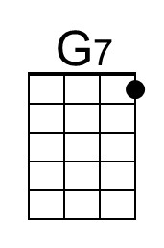 | 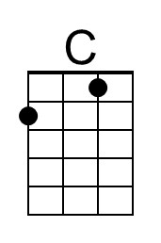 | 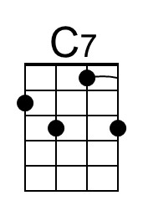
 | 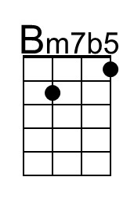 | 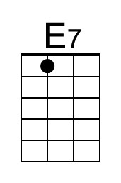 | 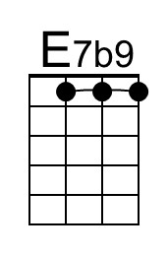 | 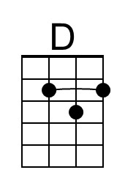 | 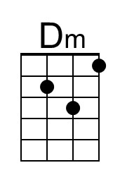

Autumn Leaves (Cm)
"Les feuilles mortes" (French lyrics) by Jacques Prévert, Music by Joseph Kosma, 1945
English Lyrics by Johnny Mercer, 1947; Autumn Leaves by Johnny Mercer (1947) (Cm)
Version 2 – 2/2 Time – 81 BPM

Intro Chords for Verse  Cm Fm7 B♭7 E♭  The falling leaves __ drift by my window,  Dm7♭5 G7 Cm  The autumn leaves __ of red and gold.  Fm7 B♭7 E♭  I see your lips, __ the summer kisses  Dm7♭5 G7 Cm  The sunburned hands, __ I used to hold  Chorus  G7 Cm  Since you went away, the days grow long  B♭7 E♭  And soon I'll hear __ old winter's song  G7♭9 G7 Cm  But I miss you most of all, my darling  F Fm G7 Cm  When au-tumn leaves start to fall.  Instrumental Verse. Repeat Chorus. Outro Gm – Dm |  |  |  |  |  | 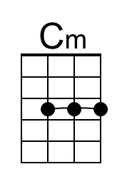 | 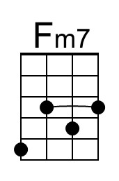
 |  |  |  |  |  | 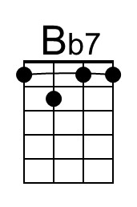 | 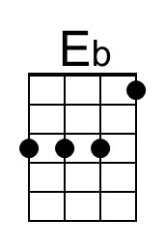
 |  |  |  |  |  | 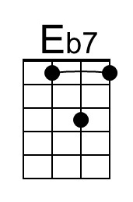 | 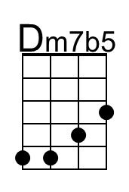
 |  |  |  |  |  |  | 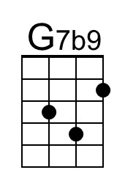
G-Tuned Uke  (Bari) | 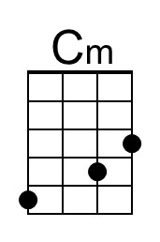 | 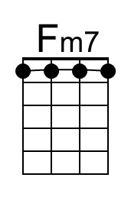 | 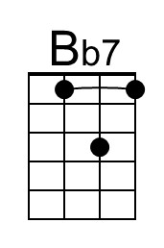 | 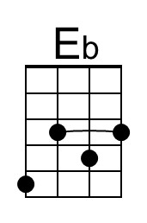 | 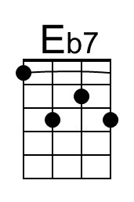 | 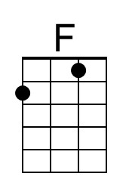 | 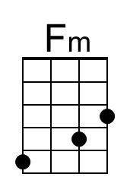
 | 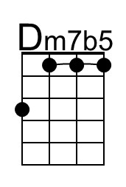 |  | 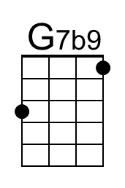 | 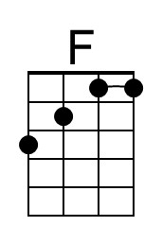 | 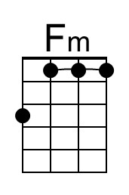

Autumn Leaves (Dm)
"Les feuilles mortes" (French lyrics) by Jacques Prévert, Music by Joseph Kosma, 1945
English Lyrics by Johnny Mercer, 1947; Autumn Leaves by Johnny Mercer (1947) (Cm)
Version 2 – 2/2 Time – 81 BPM

Intro Chords for Verse.  Dm Gm7 C7 F  The falling leaves __ drift by my window,  Em7♭5 A7 Dm  The autumn leaves __ of red and gold.  Gm7 C7 F  I see your lips, __ the summer kisses  Em7♭5 A7 Dm  The sunburned hands, __ I used to hold  Chorus  A7 Dm  Since you went away, the days grow long  C7 F  And soon I'll hear __ old winter's song  A7♭9 A7 Dm  But I miss you most of all, my darling  G Gm A7 Dm  When au-tumn leaves start to fall.  Instrumental Verse. Repeat Chorus. Outro Gm – Dm |  |  |  |  |  |  | 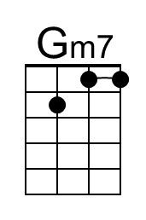
 |  |  |  |  |  | 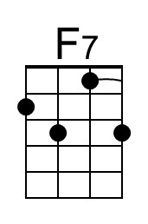 | 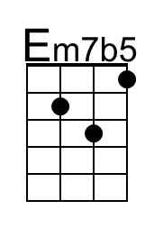
 |  |  |  |  |  | 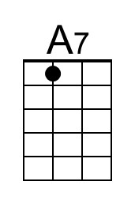 | 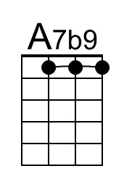
G-Tuned Uke  (Bari) |  | 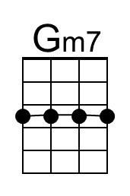 |  |  | 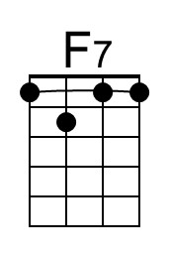 | 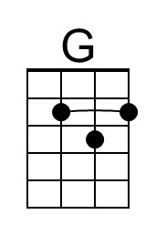 | 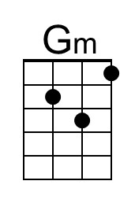
 | 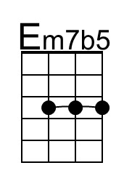 | 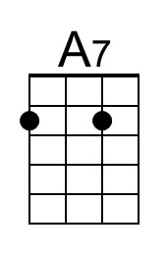 | 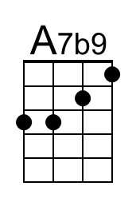 | 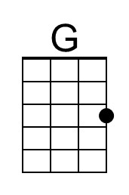 | 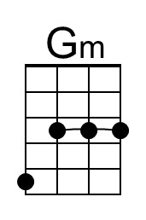

Autumn Leaves (Em)
"Les feuilles mortes" (French lyrics) by Jacques Prévert, Music by Joseph Kosma, 1945
English Lyrics by Johnny Mercer, 1947; Autumn Leaves by Johnny Mercer (1947) (Cm)
Version 2 – 2/2 Time – 81 BPM

Intro Chords for Verse.  Em Am7 D7 G  The falling leaves __ drift by my window,  F#m7♭5 B7 Em  The autumn leaves __ of red and gold.  Am7 D7 G  I see your lips, __ the summer kisses  F#m7♭5 B7 Em  The sunburned hands, __ I used to hold  Chorus  B7 Em  Since you went away, the days grow long  D7 G  And soon I'll hear __ old winter's song.  B7♭9 B7 Em  But I miss you most of all, my darling,  A Am B7 Em  When au-tumn leaves start to fall.  Instrumental Verse. Repeat Chorus. Outro Am – Em |  |  |  |  |  | 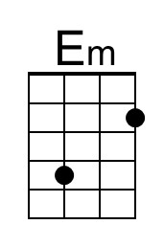 | 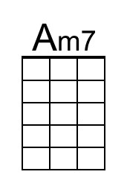
 |  |  |  |  |  | 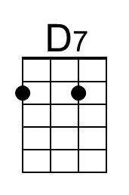
 |  |  |  |  |  | 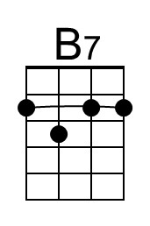 | 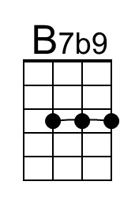
G-Tuned Uke  (Bari) | 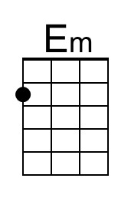 | 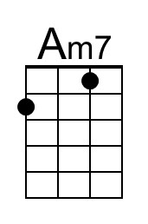 | 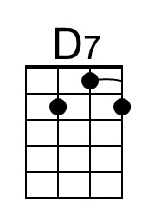 |  |  | 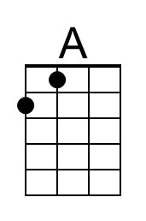
 | 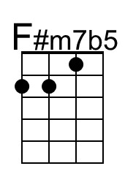 | 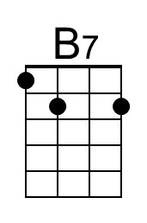 | 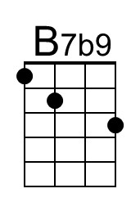 | 