**Autumn Leaves Key Am**

**(Johnny Mercer / Jacques Andre Marie Prevert / Joseph Kosma)**

**Intro: Dm G C Am Dm Em (Am x2)**

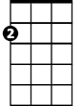

Am

**Am Dm G C**

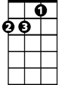

Dm



G



C

The falling leaves drift by my window

**Dm E7 Am**

The falling leaves of red and gold

**Dm G C**

I see your lips, the summer kisses

E7

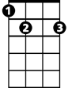

Em

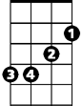

F

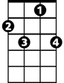

F7

**Dm E7 Am**

The sunburned hands I used to hold

**E7 Am**

Since you went away the days grow long

**Dm G C**

And soon I'll hear old winter's song

**F Dm E7 Am**

But I miss you most of all, my darling

**F7 E7 Am**

When autumn leaves start to fall

**(Instrumental first verse)**

**E7 Am**

**BARITONE**

Since you went away the days grow long



Am

C



G

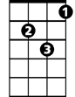

Dm

**Dm G C**

And soon I'll hear old winter's song

**F Dm E7 Am**

But I miss you most of all, my darling

**F7 E7 Am**

When autumn leaves start to fall



F

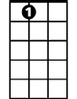

E7



Em

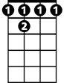

F 7

**F Dm E7 Am**

But I miss you most of all, my darling

**F7 E7 Am**

When autumn leaves start to fall

**Autumn Leaves Key Dm**

**(Johnny Mercer / Jacques Andre Marie Prevert / Joseph Kosma)**

**Intro: Gm C F Dm Gm Am (Dm x2)**



Dm

F



C



Gm



Bb

**Dm Gm C F**

The falling leaves drift by my window

**Gm A7 Dm**

The falling leaves of red and gold

**Gm C F**



A7



Am

I see your lips, the summer kisses

**Gm A7 Dm**

The sunburned hands I used to hold

**A7 Dm**

Since you went away the days grow long

**Gm C F**

And soon I'll hear old winter's song

**Bb Gm A7 Dm**

But I miss you most of all, my darling

**Bb7 A7 Dm**

When autumn leaves start to fall

**(Instrumental first verse)**

**A7 Dm**

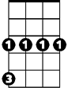

Gm

**BARITONE**

C



F



Dm

Since you went away the days grow long

**Gm C F**

And soon I'll hear old winter's song

**Bb Gm A7 Dm**

But I miss you most of all, my darling

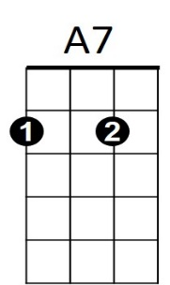**Bb7 A7 Dm**



Am

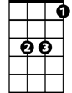

Bb

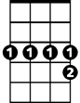

Bb7

When autumn leaves start to fall

**Bb Gm A7 Dm**

But I miss you most of all, my darling

**Bb7 A7 Dm**

When autumn leaves start to fall