
Away In A Manger
C03 C
Anonymous, late 19th Century – Tune: “Muller” by James Ramsey Murray

C C7 F C
Away in a manger, no crib for a bed,
G7 C
The little Lord Jesus laid down his sweet head.
C C7 F C
The stars in the sky looked down where He lay,
G7 C Dm G7 C
The little Lord Jesus asleep in the hay.

C C7 F C
The cattle are lowing, the baby a-wakes,
G7 C
But little Lord Jesus no crying he makes.
C C7 F C
I love Thee, Lord Jesus, look down from the sky,
G7 C Dm G7 C
And stay by my bedside till morning is nigh.

C C7 F C
Be near me, Lord Jesus, I ask Thee to stay
G7 C
Close by me forever and love me I pray
C C7 F C
Bless all the dear children in Thy tender care
G7 C Dm G7 C
And take us to heaven to live with Thee there

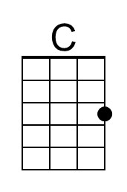 | 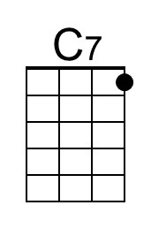 | 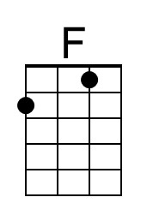 | 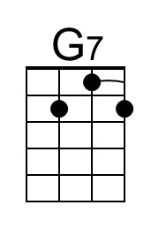 | 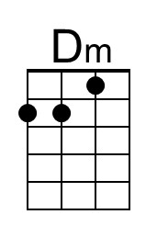
Baritone | 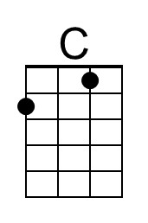 | 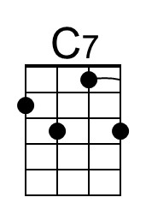 | 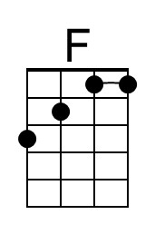 | 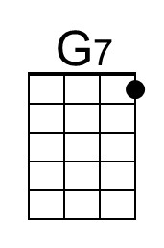 | 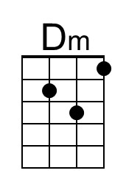

Away In A Manger
C03 G
Anonymous, late 19th Century – Tune: “Muller” by James Ramsey Murray

G G7 C G
Away in a manger, no crib for a bed,
D7 G
The little Lord Jesus laid down his sweet head.
G G7 C G
The stars in the sky looked down where He lay,
D7 G Am D7 G
The little Lord Jesus asleep in the hay.

G G7 C G
The cattle are lowing, the baby a-wakes,
D7 G
But little Lord Jesus no crying he makes.
G G7 C G
I love Thee, Lord Jesus, look down from the sky,
D7 G Am D7 G
And stay by my bedside till morning is nigh.

G G7 C G
Be near me, Lord Jesus, I ask Thee to stay
D7 G
Close by me forever and love me I pray
G G7 C G
Bless all the dear children in Thy tender care
D7 G Am D7 G
And take us to heaven to live with Thee there

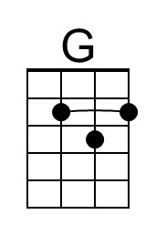 |  |  | 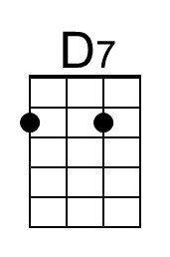 | 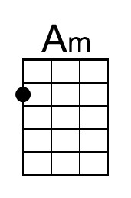
Baritone | 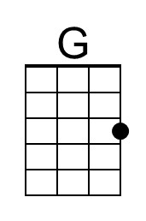 |  |  | 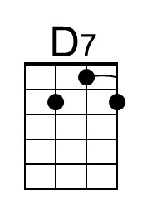 | 