**Away In A Manger**

C03

**Tune: “Muller” by James Ramsey Murray**

**C C7 F C**

Away in a manger, no crib for a bed,

F



C

**G7 C**

The little Lord Jesus laid down his sweet head.

**C C7 F C**

The stars in the sky looked down where He lay,

**G7 C Dm G7 C**

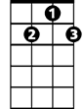

G7

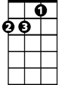

Dm

The little Lord Jesus asleep in the hay.

**C C7 F C**

The cattle are lowing, the baby a-wakes,

**G7 C**

But little Lord Jesus no crying he makes.

**C C7 F C**

I love Thee, Lord Jesus, look down from the sky,

**G7 C Dm G7 C**

And stay by my bedside till morning is nigh.

**C C7 F C**

Be near me, Lord Jesus, I ask Thee to stay

**G7 C**

Close by me forever and love me I pray

**C C7 F C**

Bless all the dear children in Thy tender care

**G7 C Dm G7 C**

And take us to heaven to live with Thee there



F

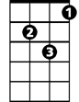

Dm

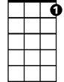

G7

C



**BARITONE**